March 16, 2026

Applicability: GEN

Internal Release Information:

C2026-007 Upgrade - Generate Missing Word Attachments

When Printing with Word Sections, if there is not a record in the Pdfs table, then PROMS needs to generate one (containing the binary of the Word document with ROs resolved). These records get cleared when we update ROs since they will need to be regenerated.

This upgrade idea is to create an admin tool that could be run overnight to generate any of these that are needed

- [Check this box if a sql query or a data fix applies to this update].

Generic External Release:
Added an Admin Tool to “Generate Missing Word Attachments”. When printing word sections, PROMS stores binary representations of Word Attachments with ROs resolved (which can greatly speed up the printing process for procedures containing large Word Sections with a lot of ROs).

Updating a specific Word Section requires that specific word section to require regeneration, When a new RO.FST is loaded or the Admin Tool “Refresh Word Attachments” are ran, those cause PROMS to require all stored Word Attachments to be regenerated. By default, if the stored information is missing, it will regenerate automatically the next time the procedure is printed. However, for plants that have an interest in speeding up potential future printing of these word sections, there is now this Admin Tool which will do the pre-generation process ahead of time.

Note that since this will generate all missing stored word attachments, it may take a considerable amount of time. As such, it is recommended to run this over a weekend the weekend after you load a new RO.FST. Similarly, if an Administrator finds a need for all saved word attachment data to need a refresh, running “Refresh Word Attachments” will wipe out all word attachment data. Thus running “Generate Missing Word Attachments” after that would cause all the word data to be regenerated. The tool will pick up where it left off in case anything unforeseen (like a power outage or system restart) occurs while it is running. (If needed) any missing word attachments will also generate for a particular procedure/section when it is printed. (This simply allows the generation to be done ahead of time, thus saving time when printing).

Plant Specific Information for Release Letter:
None

Testing Requirements:

Test 1
- Use Calaway Data (as an Admin User)
- Open the Admin Tools
- Go to the Repair tab
- Mouse over the “Generate Missing Word Attachments” button and label and check that the tooltip shows appropriately.

Test 2
- Use Callaway Data (as an Admin User) (technically any that is not multi-unit)
- Run the Admin Tool for “Refresh Word Attachments”
- Print a procedure with a large word section – time the amount of time it takes to generate the PDF
- Re-Run the Admin Tool for “Refresh Word Attachments”
- Then run the “Generate Missing Word Attachments” (note for Callaway, even a complete refresh (117 Missing Word Attachments) will only take about 9 minutes)
- After running, Print the same procedure with the large word section – time the amount of time it takes to generate the PDF – it should be shorter than the previous time.

Test 3
- Use Callaway (the same plant you used for Test 2 (as an Admin User))
- Run the “Generate Missing Word Attachments” (for a 2nd time).
- It should come back with 0 Missing Word Attachments that need Generated.

Test 4
- Use Any Data (as an Admin User) that has multi-unit (Barakah is a large test)
- Run the Admin Tool for “Refresh Word Attachments”
- Print a procedure with a large word section – time the amount of time it takes to generate the PDF
- Re-Run the Admin Tool for “Refresh Word Attachments”
- Before running this test, it is recommended you pause windows updates on your system – so that your computer does not attempt to update and restart while running the test.
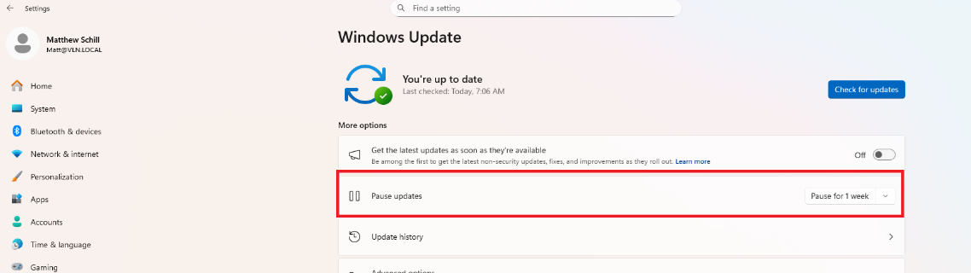
- Before running this test, it is recommended you exclude your PROMS and SQL folders and executables from Norton to avoid any possible interruptions by Norton.
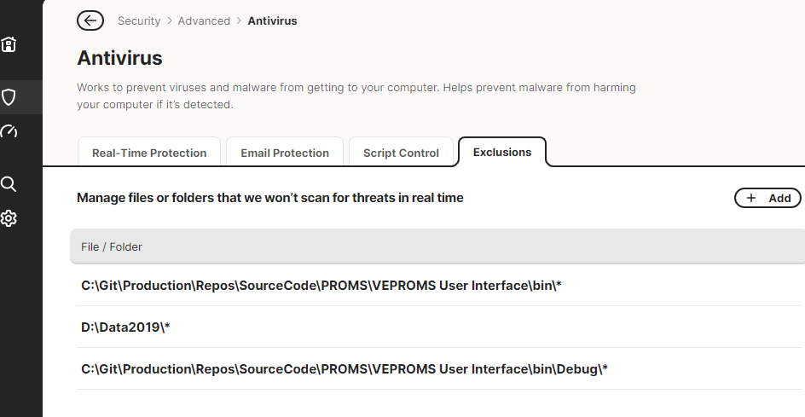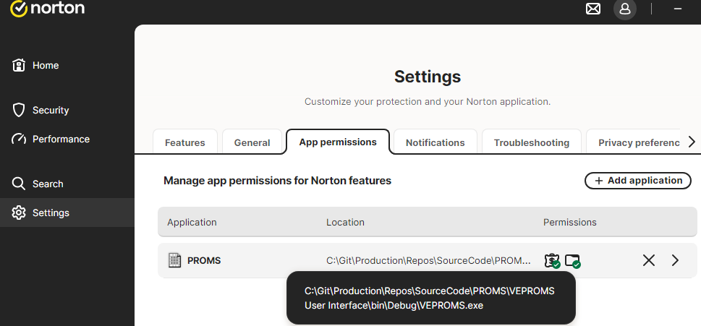
- It is recommended that you close any open Microsoft Word documents and do not open any new ones while this is running --- since this uses print (which in turn uses word behind the scenes). This will limit the currently running processes behind the scenes.
- Then run the “Generate Missing Word Attachments” over the weekend
Note: It is recommended to run this tool over a weekend. For large data sets (like Barakah) a full refresh (19924 Missing Word Attachments) would take approximately 35 hours.
- After running, get out and get back in as a different Admin User --- then Print the same procedure with the large word section – time the amount of time it takes to generate the PDF – it should be shorter than the previous time.

Changes/Additions to PROMS Manual and Training Videos:
[Do not use this section – for MRV/DMJ use]
- CSM submitted for PROMS User Manual: ____________.
- CSM submitted for training videos: ____________.

