April 30, 2026

Applicability: All Plants

Internal Release Information:
B2026-042
Add fix for null error when “Set_At_All_Level” button on the Applicability tab is disabled if user is on a RNO step.

- [Check this box if a sql query or a data fix applies to this update].

Generic External Release:
The “Set_At_All_Level” button on the Applicability tab is disabled if user is on a RNO step.

Plant Specific Information for Release Letter:
N/A

Testing Requirements:
The test is to verify that the “Set_At_All_Level” button on the Applicability tab is disabled if user is on a RNO step. Verify the wording in the tool tip for the “Set_At_All_Level”

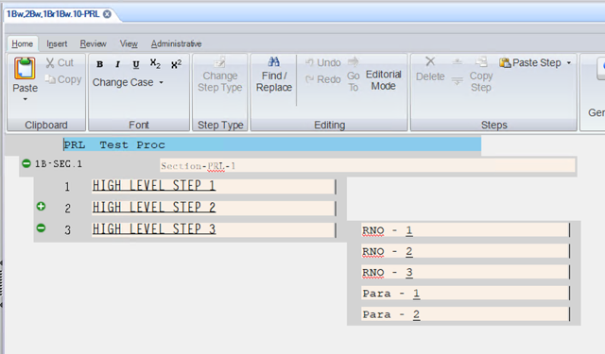

- Use VEPROMS_BWD DB.
- Create Test procedure with 3 high-level steps. Under one of the high-level steps create 3 RNO steps.
- Click in one of the high-level steps.
- Open the Applicability tab.
- Check each high-level step to make sure that they are all set to the same settings.
- Change one or two of the high-level settings in one high-level step then click the “Set All At Level” button.
- Check each high-level Applicability settings to make sure all steps settings are the same.
- Select one of the RNO steps.
- Make sure the “Set All At Level” button is disabled.
- Select another RNO step and verify the same.
- Now select a high-level step and make sure that the “Set All At Level” button is enabled.
- Review the “Set All At Level” button tool tip text to make sure the reading is correct.

Changes/Additions to PROMS Manual and Training Videos:
[Do not use this section – for MRV/DMJ use]
- CSM submitted for PROMS User Manual: ____________.
- CSM submitted for training videos: ____________.

