March 27, 2024

Applicability: Barakah

Internal Data Fixes: N/A

Internal Release:
F2024-047
Added (to all BNPP formats) a transition type that can be used to referenced procedure steps containing standard step text.

Generic External Release:
N/A

Plant Specific Information for Release Letter:
Barakah
New Transition type
A new transition "{Step Text} (Standard Step Text)" was added to all of the formats that will show step text at the transition. This is for creating a transition referencing standard text.

Testing Requirements:
Use Barakah data
- Update formats
- Open an EOP to a step editor section.
- Add a test step and add a "{Step Text} (Standard Step Text)” transition (located last in the transition list). Select the EOP-SSL procedure, then the Standard Steps section.
- Verify steps, sub-steps, Notes, RNOs, etc. are available in the step list.
- Select one of the steps listed
- Verify the step text is put in as the transition

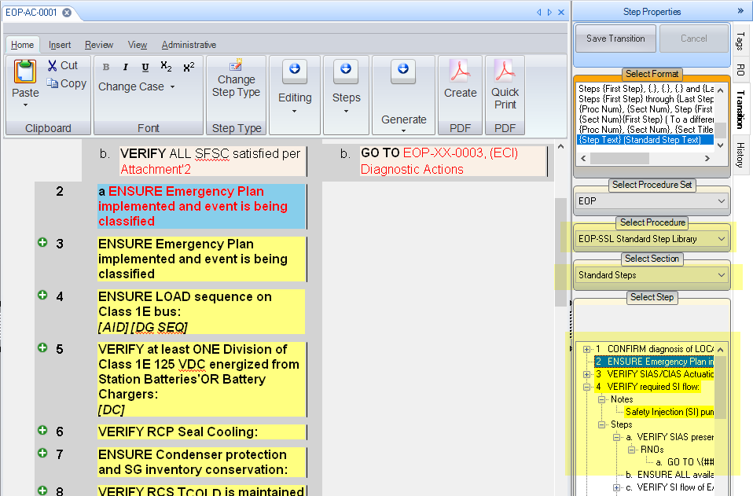

Changes/Additions to User Documentation:

N/A

