2/27/2024

Applicability: B2024-009: Vogtle Alarm Format : Front Matter Notes and Cautions not found in Global Search for step types

Internal Data Fixes: NA

Internal Release:

B2024-011: Vogtle Alarm Format : Global Search isn't giving all results when searching Local Alarms for Front Matter Notes and Cautions (Nothing typed into the text box). In the Vogtle Alarm Format, a flag needed to be set on the Front Matter Cautions and Notes step types, InMenu=true which allows the step type to be included in Search for Step Type. This was already set on Front Matter Warnings

Generic External Release: NA

Plant Specific Information for Release Letter: NA – format still under development

Testing Performed:

See Testing Required.

Testing Requirements:

Using the Vogtle sql database:

£ In an ARPs/Local procedure, such as ZAS-ARP-014, add 3 high level steps and add a Front Matter Note off one of them, a Front Matter Caution of another, and a Front Matter Warning off another
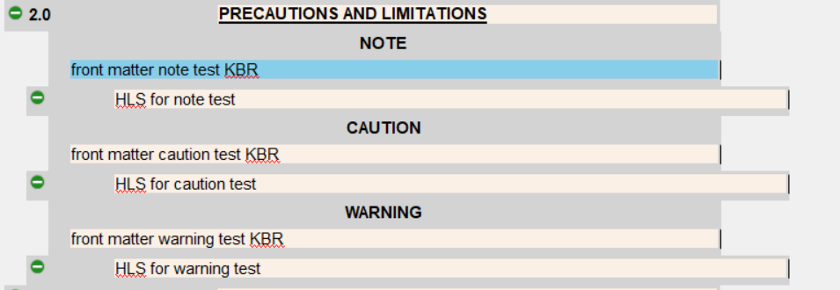
£ Expand the Tools panel and from Search tab expand the Search By Step Element tree to verify that the Front Matter Caution & Warning exist under the Caution step type and the Front Matter Note exists under the Note step type
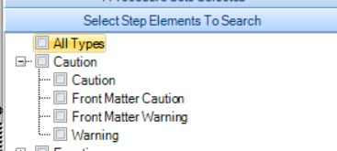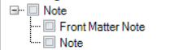

£ Select the Front Matter Caution, Front Matter Warning and Front Matter Note types and then select the Search button, no text should be entered. Verify that the steps created in first part of test are included in the search results:
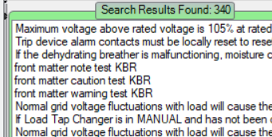

Changes/Additions to User Documentation: NA

