April 28, 2026

Applicability: GEN

Internal Release Information:

C2026-008 - Re-Architect RO.FST to include RO Modification date/time and use those when updating ROs from the RO.FST

- [Check this box if a sql query or a data fix applies to this update].

Generic External Release:
Performance improvement related to the loading of ROs.
- Re-Architected the RO.FST to include RO Modification date/time and use those when updating ROs from the RO.FST.
- Modified the loading of the RO.FST in PROMS so that when updating ROs via a new RO.FST that it will only look at specific items that contain ROs.
- Sometimes a new RO database may be loaded for only one set (despite applying to multiple sets) – This can cause RO loading messages swapping between sets as it swaps between different versions of the loaded RO database. Now, when this occurs and you go into a set that can utilize a new RO database, it will prompt the user to see if they want to update the ROs to the latest (if they can check out the working draft to update it). This will improve consistency as well as loading times between different sets.

Plant Specific Information for Release Letter:
None

Testing Requirements:

Test 1 – Access RO DB with old RO FST (making sure a RO FST created with an old version will still work)
- Use any Data with ROs.
- Using another version of PROMS, update to that versions sql fixes and formats.
- Add a RO to a step or pick a step that has a RO.
- Modify the RO, save, and create a new ro.fst.
- Using this testing version of PROMS, update the sql fixes for the database.
- Go into PROMS and update values by clicking on the Update RO Values button in the Ribbon.
- Once the progress bar at the bottom designates that ROs have updated, verify that RO Values in a step have updated and that the RO tree has updated (click on a step, open Step Properties -> click the RO tab & navigate to the RO in the tree)
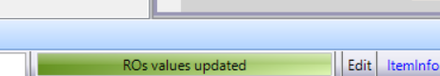

Test 2 – Access RO DB with new RO FST (Updating without date to one with date – i.e. first use of new RO FST) / Test Update via Step Tab Ribbon
- Use another database not used for testing Step 1 or restore a database.
- Update SQL fixes to this current version.
- Add a RO to a step in PROMS or pick a step that has a RO.
- Modify the RO, save, and create a new ro.fst.
- Update values using the RO FST by clicking on the Update RO Values button in the Step Tab Ribbon
- Once the progress bar at the bottom designates that ROs have updated, verify that RO Values in a step have updated and that the RO tree has updated.

Test 3 – Access RO DB with new RO FST (Subsequent Updates - Updating data with date) / Test Update via Step Tab Ribbon
- Use Data used in Test 2
- Add ROs to different steps in PROMS or pick steps that have ROs.
(would choose a couple different step types, like a high level, an RNO, a substep with a table with the RO inside the table).
- In the RO Editor, update the ROs that were used and add a new RO.
- Save and create a new RO.FST.
- In PROMS, update the RO values using the Update RO Values button in the Step Tab Ribbon.
- Once the progress bar at the bottom designates that ROs have updated, verify that RO Values in each step have updated and that the RO tree has updated to include both the new and changed ROs.

Test 4 –Test Update via Version Properties
- Use Any Data
- Add a RO to a step in PROMS or pick a step that has a RO
- Using current version of the RO Editor, update the RO, add a new RO also and Create a RO FST
- Using the current version of PROMS, update values using the RO FST by clicking on the Working Draft -> Properties -> Referenced Objects -> Update RO Values
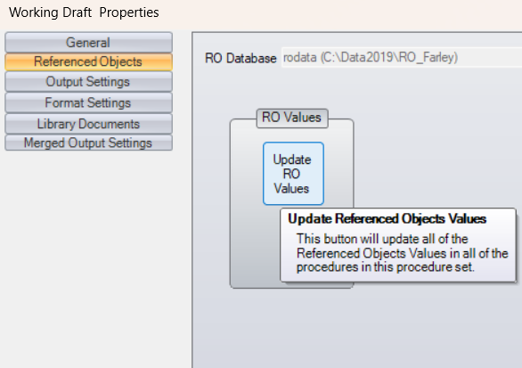
- Once the progress bar at the bottom designates that ROs have updated, verify that RO Values in a step have updated and that the RO tree has updated to include both the new and changed RO.

Test 5 –Test Update via Tree View
- Use Any Data
- Add a RO to a step in PROMS or pick a step that has a RO
- Using current version of the RO Editor, update the RO, add a new RO also and Create a RO FST
- Using the current version of PROMS, update values using the RO FST by Clicking on the Tree and Working draft -> Update RO Values
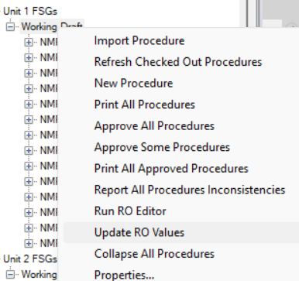
- Once the progress bar at the bottom designates that ROs have updated, verify that RO Values in a step have updated and that the RO tree has updated to include both the new and changed RO.

Test 6 – Test Update via Admin Tools / multi-set test
- Use Any Data
- Add a RO to a step in PROMS for 3 different sets that use the same RO database
- Using current version of the RO Editor, update the RO, add a new RO also and Create a RO FST
- Using the current version of PROMS, update values using the RO FST by utilizing the Admin Tools Update ROs
V button -> Administrative Tools -> Links -> Update RO Values
Select 2 of the 3 sets to update
- Once the progress bar at the bottom designates that ROs have updated, verify that RO Values in a step have updated for the 2 sets that were selected and that the RO tree has updated to include both the new and changed RO.
- For the Set that was not selected as part of the update, open a Procedure
- You will be prompted with:
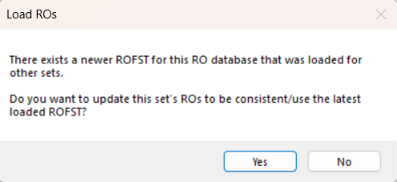
- Select No
- Verify that the RO Values were not updated and clicking in the Step Properties RO Tree shows the non-updated values

Test 7 –Test Update via Display RO is blocked when checked out
- Use same data as Test 6
- With the Step open that you did not update in Test 6, open another copy of PROMS with another user
- Go to the Step that is checked out via the original user
- You should not get prompted with

Test 8 –Test Update via Display RO
- Use same data as Test 6/7
- Close out all but 1 user
- Either close and reopen the procedure that did not update or swap tabs away and back to that procedure
- This time when prompted about a newer ROFST, select yes
- Once the progress bar at the bottom designates that ROs have updated, verify that RO Values in a step have updated and that the RO tree has updated to include both the new and changed RO.
- Verify that swapping tabs away/back to that procedure now no longer prompts regarding a newer ROFST
- Verify that closing and reopening that procedure now no longer prompts regarding a newer ROFST

Test 9 – Test Deleted RO
- Use same data as Test 6/7/8
- Using current version of the RO Editor, add a new RO also and Create a RO FST
- Using the current version of PROMS, update values using the RO FST (using any method)
- Add the new RO to a Step
- Using current version of the RO Editor, delete the new RO also and Create a RO FST
- Using the current version of PROMS, update values using the RO FST (using any method)
- Once the progress bar at the bottom designates that ROs have updated, Verify that the RO was deleted in the Step Properties RO Tree & that the step that you had previously added the RO to now has the annotation for the Deleted RO (i.e. changed the link to text).

Test 10 –Test Parent Child / Multi-unit & Word Section ROs
- Use any data that is multi-unit
- Add a multi-unit RO to a step in PROMS and also a word section and save the Word section. Do not open the Word section between updating the RO.FST and printing. Opening the Word section and saving it in PROMS clears the pdf.
- Print the step / section to establish a base
- Using current version of the RO Editor, update one of the unit specific items for the RO and Create a RO FST
- Using the current version of PROMS, update values using the RO FST by clicking on the Update RO Values button in the Step Tab Ribbon
- Once the progress bar at the bottom designates that ROs have updated, verify that RO Values in a step have updated and that the RO tree has updated (click on a step, open Step Properties -> click the RO tab & navigate to the RO in the tree)
- Verify that it prints correctly with the new unit-specific RO Values.

Test 11 – SQL Server RO DB
- Convert a RO database to use SQL Server instead of MS Access (or use a ro database already using SQL Server)
- Using the RO editor, Create a RO FST
- In PROMS, update values using the RO FST
- Add a RO to a step in PROMS
- In the RO Editor, change the RO
- Create a new RO FST
- In PROMS, update values using the RO FST
- Once the progress bar at the bottom designates that ROs have updated, Verify that RO Values in a step have updated and that the RO tree has updated.

Test 12 – Additional Testing
- For various plants, follow Test 1 instructions to verify old version RO.FST and updating with new version.
- For various plants, use the current testing executables and make changes to ROs, create ro.fst’s, and update RO values.
- When updating RO values, use the four methods: Administrative tab, Working Draft menu, Properties|Referenced Objects, and Admin Tools.
- Each time RO values are updated, verify the RO tree is also updated.

Changes/Additions to PROMS Manual and Training Videos:
[Do not use this section – for MRV/DMJ use]
- CSM submitted for PROMS User Manual: ____________.
- CSM submitted for training videos: ____________.

