May 9, 2024

Applicability: Generic – Generate PDF Links

Internal Data Fixes: N/A

Internal Release:

B2024-031
When link information is created in a PDF during print and there is an existing PDF of the same name there, PROMS creates the new PDF with a unique file name (appending a number to the name). Transition links can become invalid because the link information stores the PDF file name without the appended number. When printing using the Create RO and Transition Hyperlinks option, PROMS should not try to make unique PDF file names and instead replace the existing PDF file with the new one.

Generic External Release:
Generate PDFs with Links
PROMS will now automatically turn off the creating of a unique PDF file name (appending a number to make it unique) and instead replace the PDF file of the same name.

Plant Specific Information for Release Letter:

N/A

Testing Requirements:
Use Beaver Valley data
- Navigate to the Working Draft node for the SD EOPs Unit 1 procedure set and open the properties page.
- Set the PDF location to an empty folder locally on your computer (or just clear out that folder)– on the Output Settings tab. Save and close. – Note that the PDF Location folder must exist before printing the procedrues.
- Right click on the Working Draft again and select to print all procedures.
- On the Print dialog select to Create RO and Transitions Hyperlinks
- Click on Create PDFs

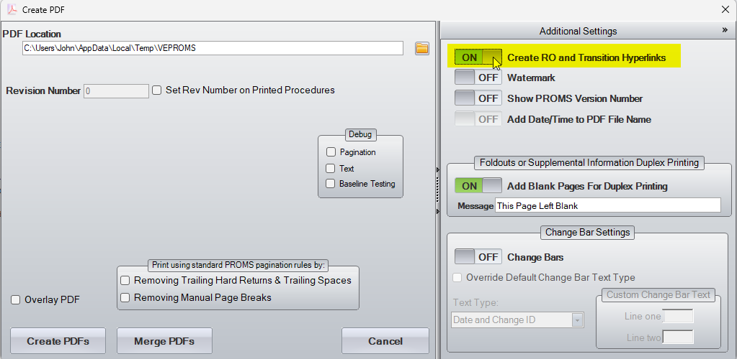

- Edit procedure SD-5 and add a new step3

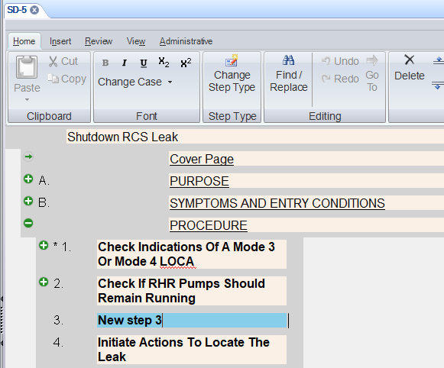

- Edit procedure SD-0 and add a test sub-step with a transition to the new step 3 in procedure SD-5.

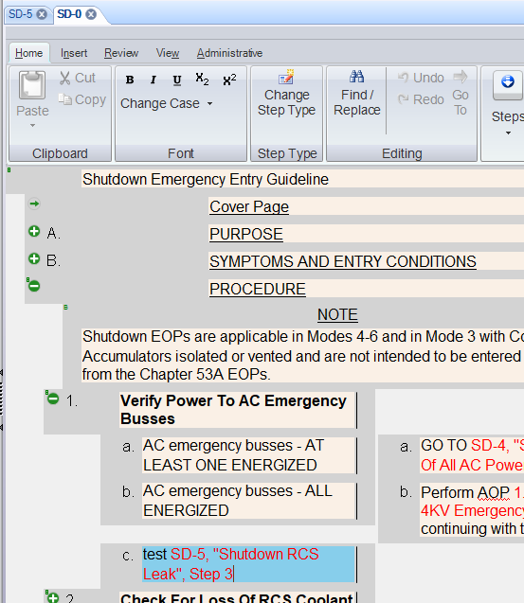

- Print procedure SD-5 with the Create RO and Transition Hyperlinks turn on
- Print procedure SD-0 with the Create RO and Transition Hyperlinks turn on
- View the SD-0 PDF and click on the test transition to SD-5 step 3
- Verify Adobe jumps to the page containing that new step 3

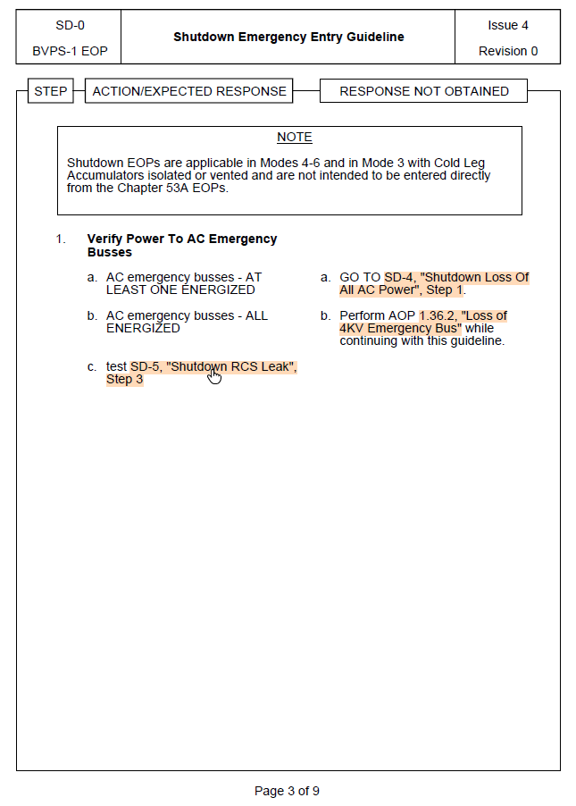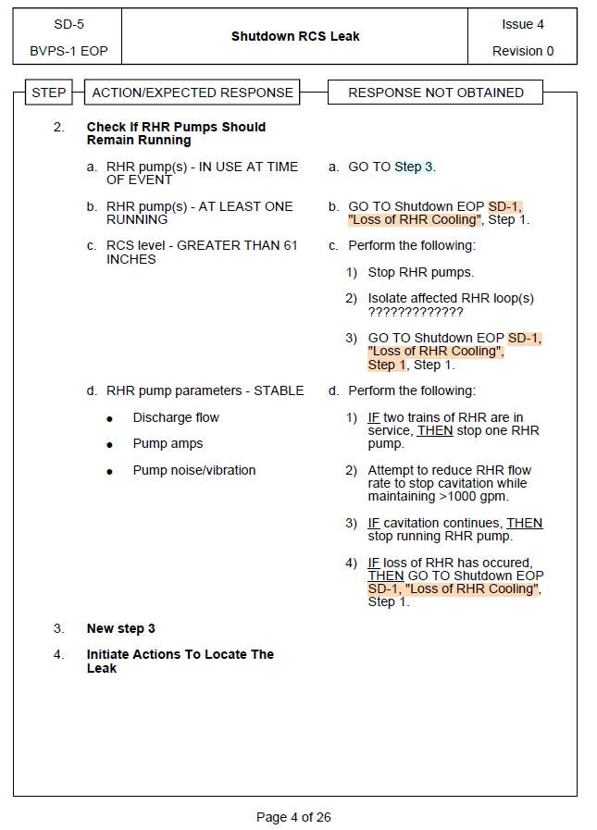

Changes/Additions to User Documentation:

N/A

