1/9/2023

Applicability: B2022-134: Update of ROs with ‘<’ when in table cell crash

Internal Data Fixes: NA

Internal Release:

B2022-134: Update of ROs with ‘<’ when the RO is included in a table cell crashed. The ‘<’ symbol is a reserved symbol in xml and grid data is stored as xml. The ‘>’ symbol must also be handled. Note that when the RO is inserted, the code replaced these symbols with the xml ‘&lt;’ and ‘&gt;’ characters. The code that does the update of ROs needed to have this same code.

Generic External Release:

Updating of Referenced Objects (ROs) when an RO has a ‘<’ or ‘>’ symbol and this RO is included in a table cell was crashing. This has been fixed.

Plant Specific Information for Release Letter: NA

Testing Performed:

See Testing Required.

Testing Requirements:

Using the Ginna sql database and a local RO database (the test adds new ROs):

£ In Proms verify that the path to the RO database, from Working Draft Properties/Referenced Objects, is the local RO database
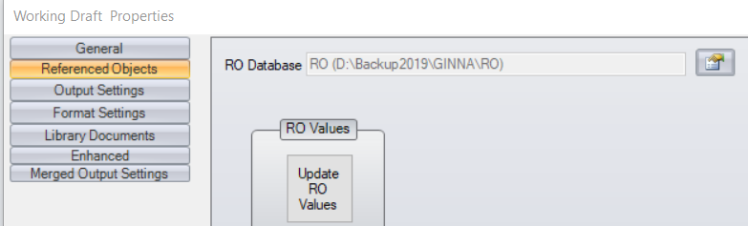

£ Bring up the RO Editor; add 2 new ROs, one containing ‘<’ and one ‘>’ such as 'a<b' and ‘a>b’; Create RO.FST

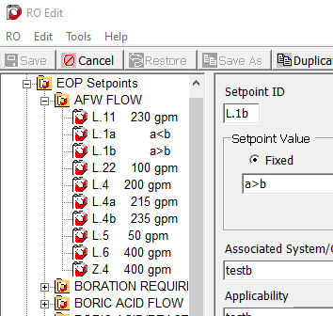

£ In Proms, update ROs, and then create a table with at least 2 cells. Insert these 2 ROs ('a<b' and ‘a>b’) in two of the cells

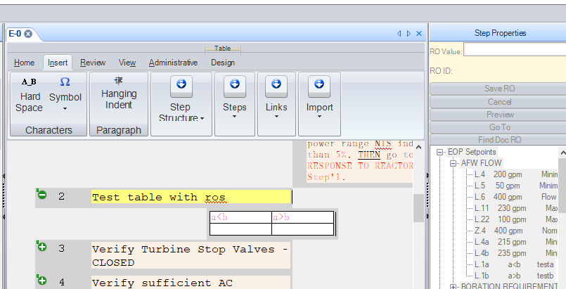

£ Close the procedure and go back to RO Editor, modify those ROs, for example change to 'a<c', and ‘a>c’. Create RO.FST

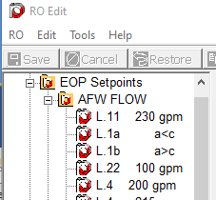

£ In Proms, update ROs. Verify that this does not crash.
£ Go back to the table that was created in the earlier step and verify that the 2 ROs have the change.

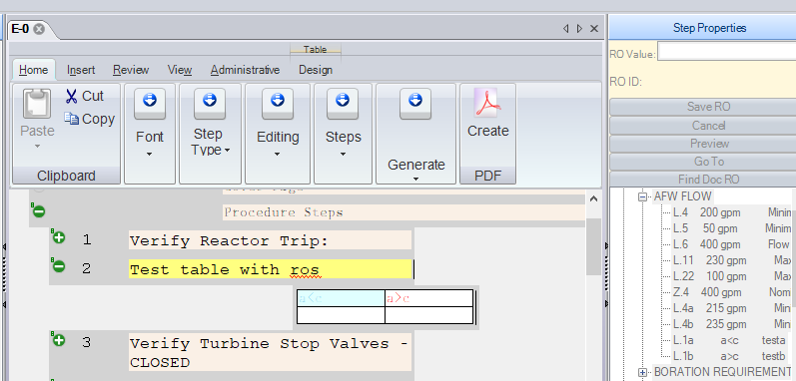

Changes/Additions to User Documentation: NA

