October 15, 2026

Applicability: GEN

Internal Release Information:

B2026-078 Hide Delete and Open Button for Library Documents with any occurrences.

These buttons only come into play when Importing Word Docs as Library docs and thus should only show in that case.

- [Check this box if a sql query or a data fix applies to this update].

Generic External Release:
Made change to hide delete and open buttons on Library Documents tab when these buttons were not valid (these buttons were only enabled/only came into play when Importing Word Documents as Library Documents).

Plant Specific Information for Release Letter:
N/A

Testing Requirements:
- Use any db in PROMS
- Open the Tools -> Library Documents tab
- The Delete and Open buttons should not show for any Library Docs with a count.
- Use the “Import Existing Word Document” button and pick a word docx file
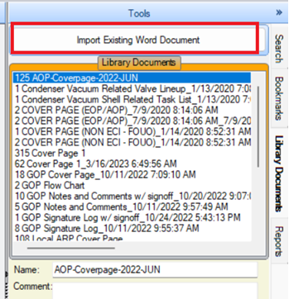
- Open should show and work if the newly imported Word Doc is selected
- Delete should show and work if the newly imported Word Doc is selected

Changes/Additions to PROMS Manual and Training Videos:
[Do not use this section – for MRV/DMJ use]
- CSM submitted for PROMS User Manual: ____________.
- CSM submitted for training videos: ____________.

