8/8/2024

Applicability: Plants with Enhanced documents

Internal Release Information:
B2024-038
From the tree view, menu options for Paste/Replace of a section that has links has been eliminated. Also, a fix was made to the program for crashing if the pasted section was displayed in the editor.

☐ [Check this box if a sql query or a data fix applies to this update].

Generic External Release:
From the tree view, menu options for Paste/Replace of a section that has links has been eliminated. Also, a fix was made to the program for crashing if the pasted section was displayed in the editor.

Plant Specific Information for Release Letter:
N/A

Testing Requirements:
Use the Beaver Valley sql database:
- Expand the EOPs/Unit1/ES-0.0 procedure in the tree view and select the procedure to open in the editor
- From the tree view, copy the PROCEDURE section
- Bring up the context menu on A. PURPOSE to verify that there is no Replace Section menu item
- Expand the EOPs/Unit1/ES-0.1 procedure in the tree view
- Bring up the context menu ES-0.1/A. PURPOSE to verify that there is no Replace Section menu item
- Position over ES-0.0/A. PURPOSE and select to Paste Section After to verify that the program does not crash & the new section is displayed in the editor. NOTE this does not link to the correct section – a separate bug, B2024-059 has been written for this.

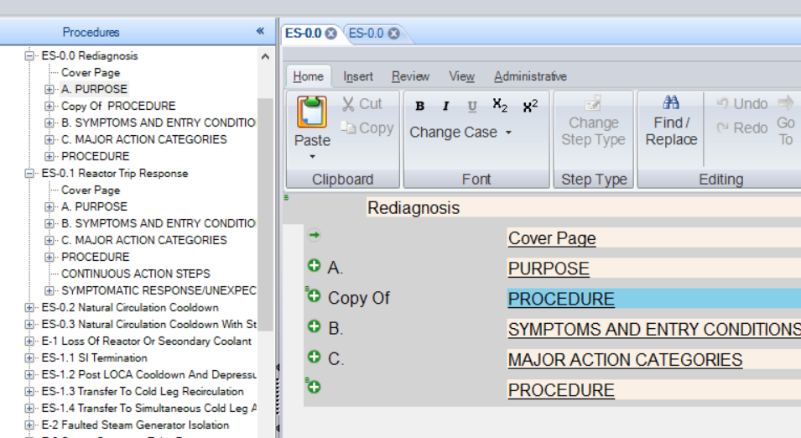

Changes/Additions to PROMS Manual and Training Videos:
☐ CSM submitted for PROMS User Manual: _______________________________________

☐ CSM submitted for training videos: _______________________________________

