March 16, 2026

Applicability: Barakah

Internal Release Information:
C2026-030
Barakah asked that the white space between the procedure number and procedure title be reduced when the KEPCO number is not printed

- [Check this box if a sql query or a data fix applies to this update].

Generic External Release:
N/A

Plant Specific Information for Release Letter:
Barakah - All formats
PROMS will now reduce the amount of white space between the procedure number and procedure title on the Cover Page when the KEPCO number is not printed.

Testing Requirements:
Use Barakah data
- Update formats
- Do a Quick Print the Cover Page section for Alarm procedure [1N2}-OP-ARP-AF-001 in the MCR Alarms set – keep this page open in Adobe
- Open the Procedure Specific Information for that procedure and un-check the “Use in Cover and Page Headers

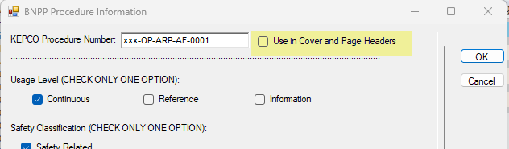

- Quick Print the Cover Page section again and verify the procedure title is better centered before the procedure number and the revision number”

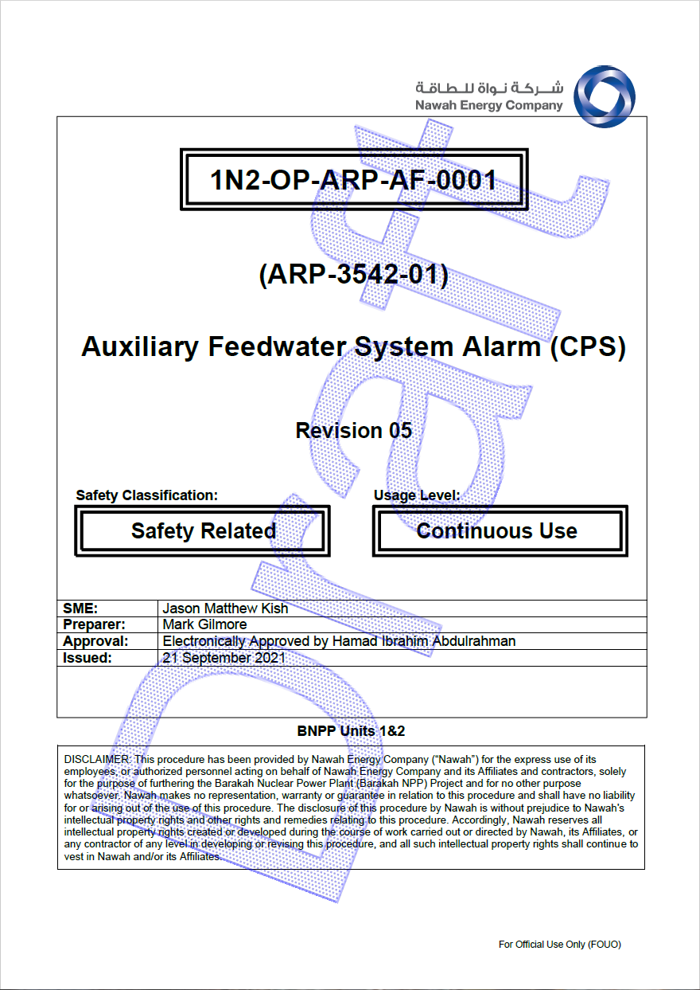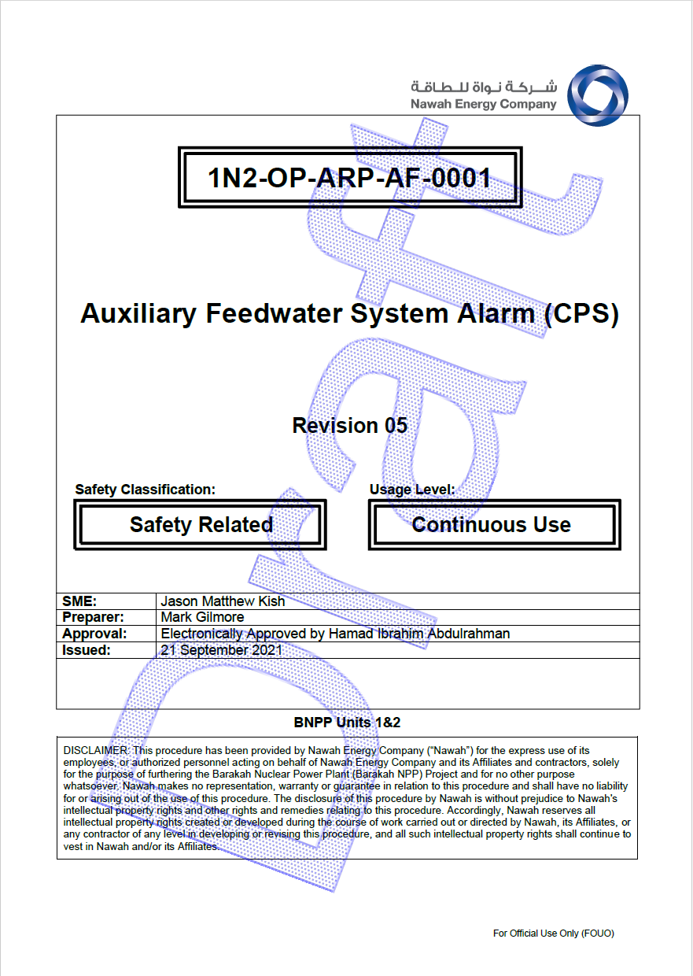

- Do the same test for EOP procedure EOP-AC-001 in the EOP procedure set

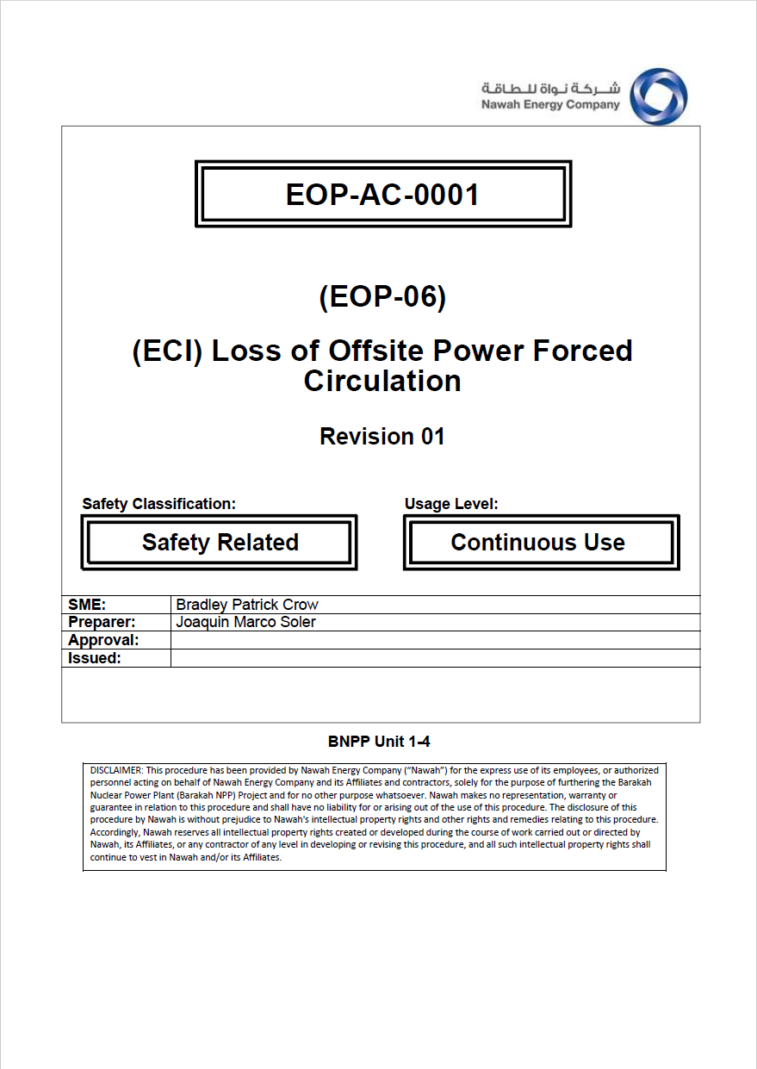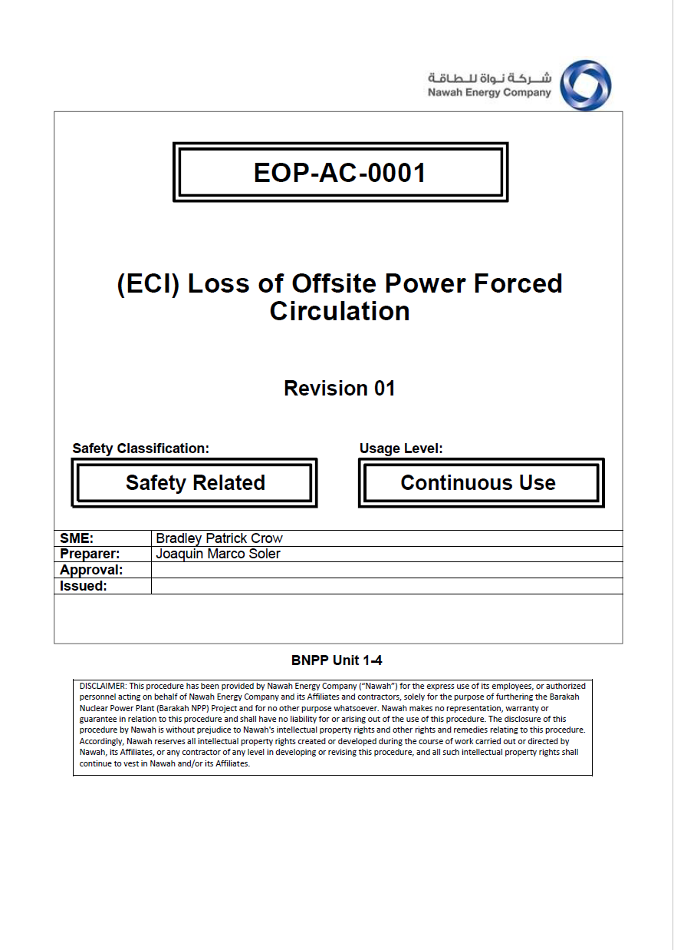

- Do the same test for OP-PT-AF-5105 in the PTs procedure set”

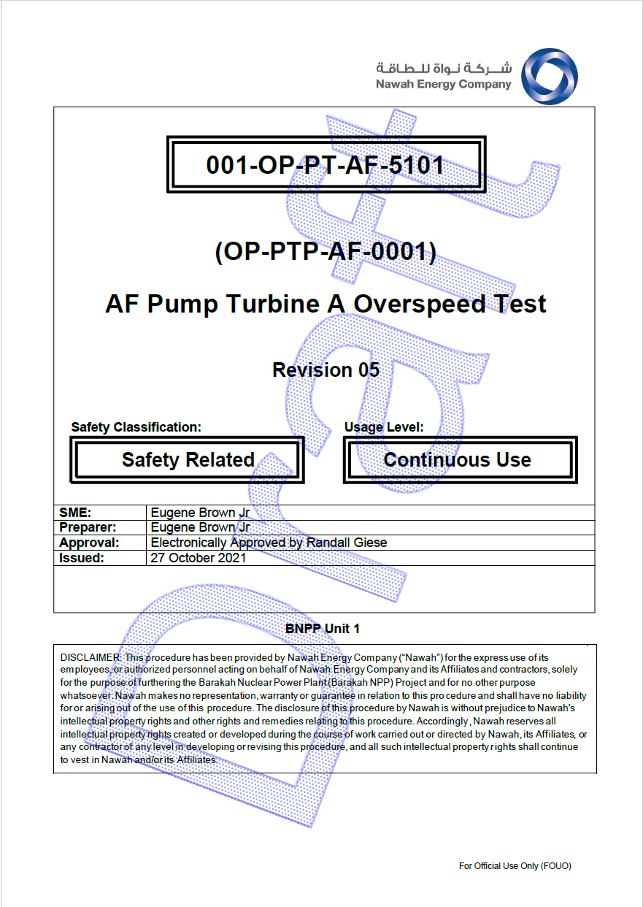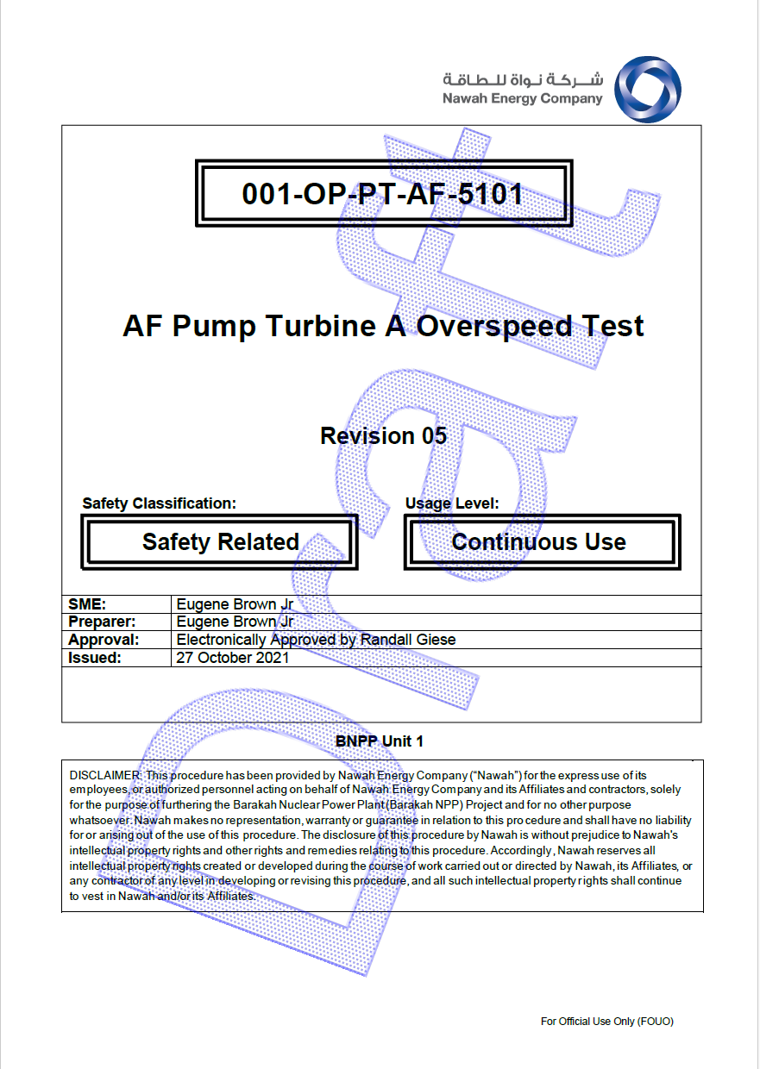

Changes/Additions to PROMS Manual and Training Videos:
[Do not use this section – for MRV/DMJ use]
- CSM submitted for PROMS User Manual: ____________.
- CSM submitted for training videos: ____________.

