October 24, 2023 Barakah ECI Footer

Applicability: Barakah

Internal Data Fixes: N/A

Internal Release:
F2023-138 For all of the used Barakah formats, set the color of the ECI footer text to Red and changed the font size to 12pt and font style to Bold

Generic External Release:

N/A

Plant Specific Information for Release Letter:
Barakah
The ECI footer text will print in Arial 12pt Bold and as Red text

Testing Requirements:
Use Barakah Data
- For an EOP procedure, open the Procedure Specific Information and check the box to print the ECI foot.

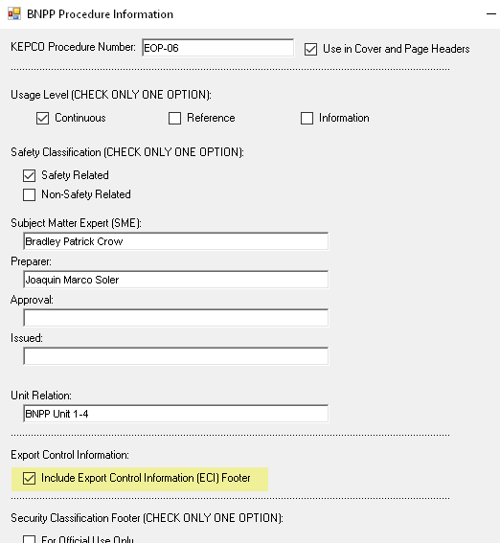

- Print the procedure and verity the ECI text prints as Arial 12pt Bold and the text is red on all of the pages

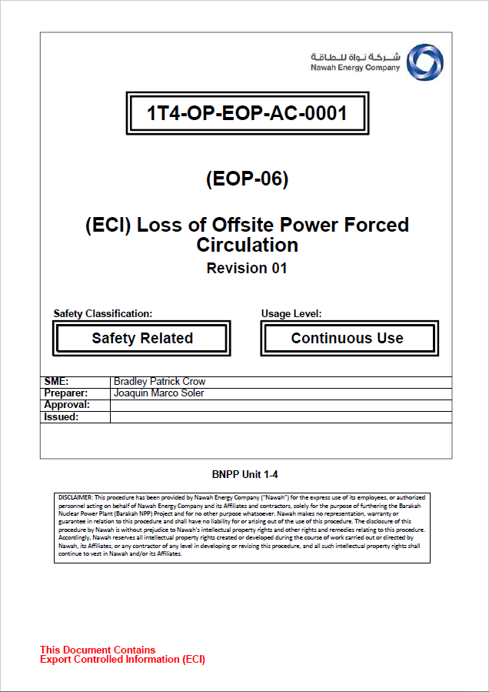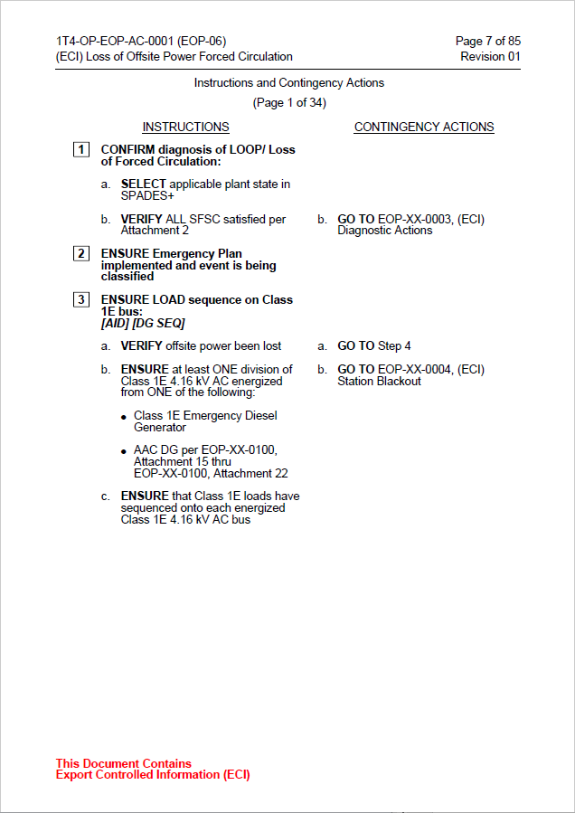

- Do the same as above for an AOP procedure
- Do the same as above for an Alarm procedure
- Do the same as above for a Background Document procedure
- Do the same as above for an NOP procedure

Changes/Additions to User Documentation:

No changes or additions needed.

