April 4, 2024

Applicability: Generic EOP (ERG) format

Internal Data Fixes: N/A

Internal Release:

F2024-051
Generic EOP Format, page width of Attachment section

Generic External Release:

Generic EOP Format
Adjusted the width of the Word Attachment section to that it does not print past the page border

Plant Specific Information for Release Letter:

N/A

Testing Requirements:
Use ERG Rev 4 data
- Update formats
- Print procedure ECA-0.0
- Verify the text does not print into or past the right page border

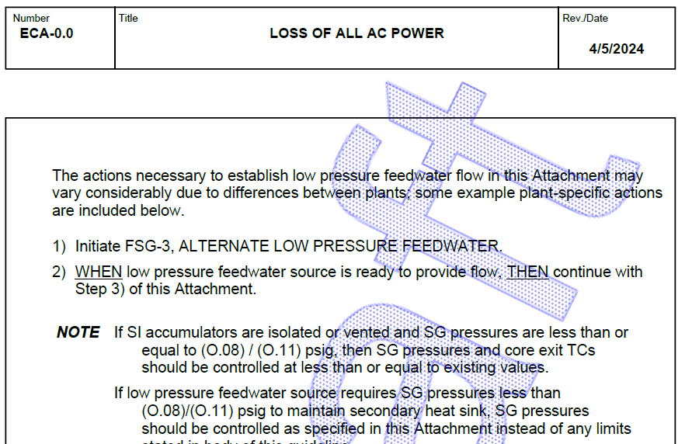

Changes/Additions to User Documentation:

N/A

