January 2, 2026

Applicability: GEN

Internal Release Information:

B2025-065 When Printing a Word Section containing XY Plot ROs - when there is a title on the XY Plot, only the first line is indented.

- [Check this box if a sql query or a data fix applies to this update].

Generic External Release:
When Printing a Word Section containing XY Plot ROs with a title on the XY Plot, when there is spacing before the RO Token in the Word Section, PROMS will now indent the entire RO (not just the first line).

Plant Specific Information for Release Letter:
N/A

Testing Requirements:
- Use Ginna data
- Open: EOP_AP Figures -> Fig-1.0
- Open the Word section and add a couple spaces before the RO <SP-K.1>
- Exit the word section and save changes (note that generation is done when saving so have to save changes – if you find one with spaces already before it and do not re-save it then it will not regenerate).
- Print Fig-1.0
- PROMS should now indent the XY Plot by the number of spaces (not just the first line).
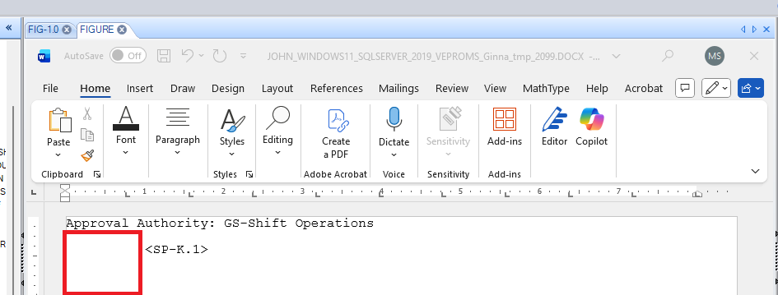
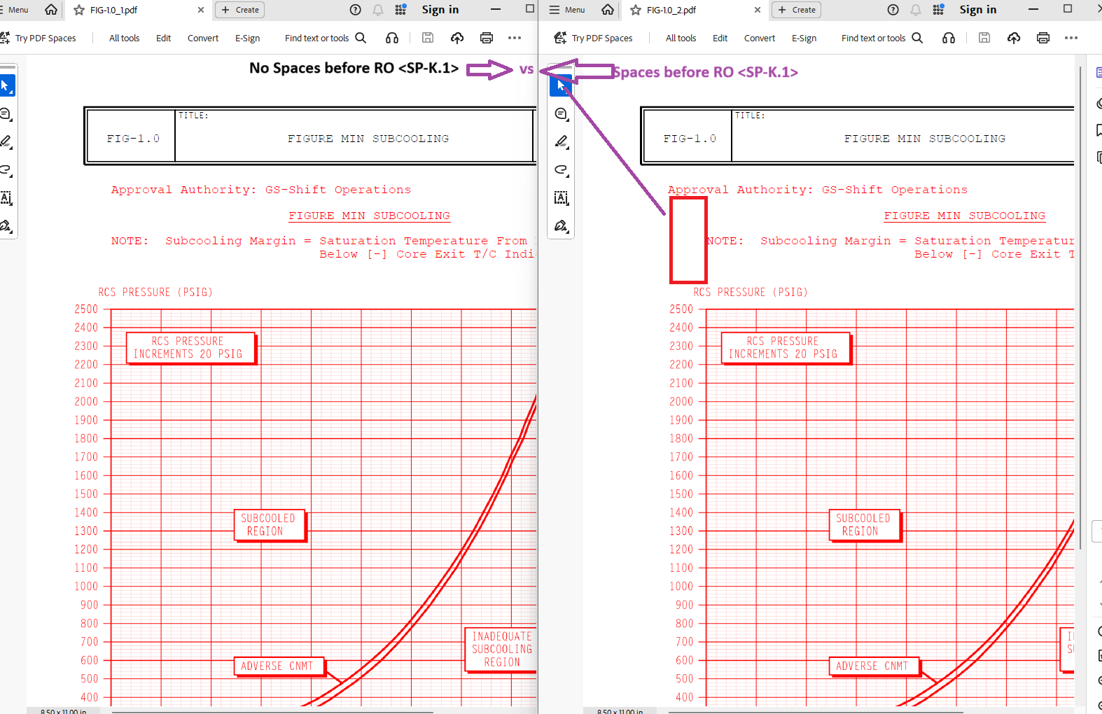

Changes/Additions to PROMS Manual and Training Videos:
[Do not use this section – for MRV/DMJ use]
- CSM submitted for PROMS User Manual: ____________.
- CSM submitted for training videos: ____________.

