November 10, 2023

Applicability: Barakah and Generic

Internal Data Fixes: N/A

Internal Release:
B2022-046
Copy/Paste table Rows, Columns, or selected Cells was not updating RO and Transition links with new RO or Transition Usage numbers. This was noticed when Unit Designators were in the cells and the procedure was printed for a specific unit – it would not resolve the unit designators. The problem extended to regular RO values and Transition links. Not having a unique RO or Transition Usage ID would prevent RO value and Transition updates

Generic External Release:
Tables
PROMS will now properly handle the copy/paste of table rows, columns, and individual cells that contain RO and Transition links.

Plant Specific Information for Release Letter:
Barakah
Tables
PROMS will now properly handle the copy/paste of table rows, columns, and individual cells that contain RO and Transition links.

Testing Requirements:
Use Barakah data
- Edit a NOP in the 1N2 3N4 1T4 NOP set
- Add a test step in a step editor section
- Add a text table with at least 1 row and 3 columns
- Add a unit designator RO the first cell
- Add a unit specific RO in the cell of the next column in the same row
- Add a transition in the cell of the next column in the same row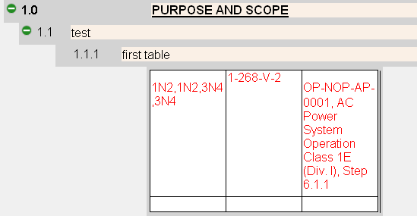

- Print the procedure for a specific unit and verify
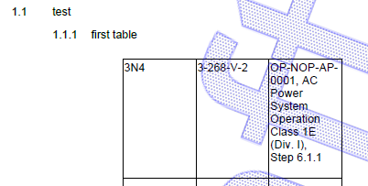
- Add another sub-step with an empty table of the same size
- Copy the row containing the ROs and Transition

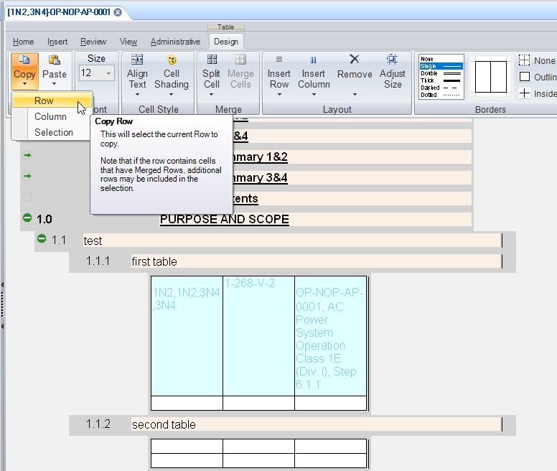

- Paste/replace the row in the new table

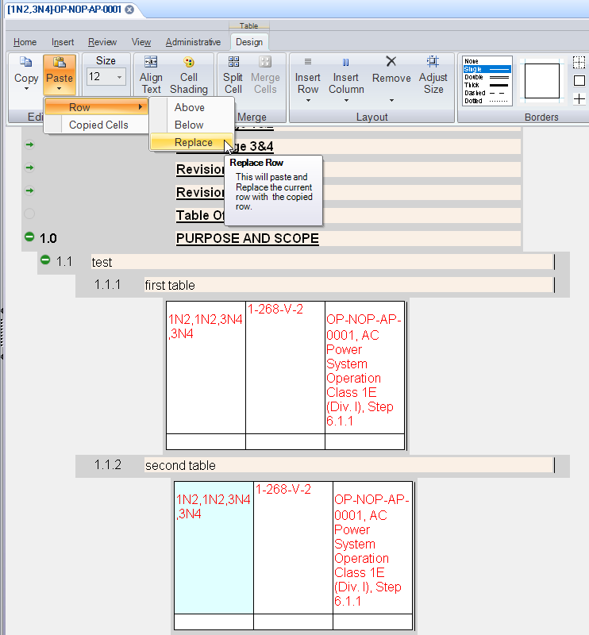

- Print for a specific unit an verify the correct unit numbers are used in the ROs

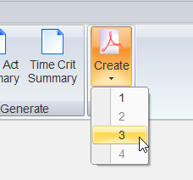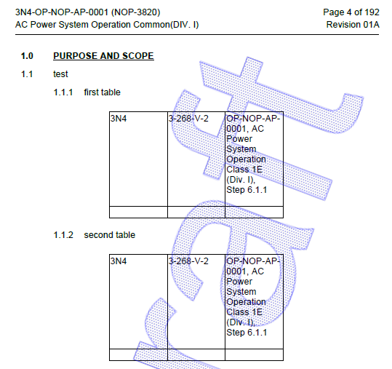

- Return to the editor and verify the transition was not converted to text (no Annotation saying it was converted to text)
- Restore the second table to where it was empty (or delete it and add a new one)
- Copy a column containing a RO from the first table and paste it into the other table
- Print and verify the RO has the correct unit number
- Restore the second table to where it was empty (or delete it and add a new one)
- Copy a single cell (using the table buttons not the windows clipboard) containing a RO from the first table and paste it into the other table
- Print and verify the RO has the correct unit number

Changes/Additions to User Documentation:

No changes or additions needed

