November 15, 2024

Applicability: All Plants

Internal Release Information:
C2024-028 Add an enhancement to Admin Tools -> Refresh Transitions. Transitions with bad links that cannot be auto-fixed, will now add an annotation of “Bad Transition Link” (which can then be searched for and manually resolved.)

- [Check this box if a sql query or a data fix applies to this update].

Generic External Release:
Enhancement added for Admin Tools -> Refresh Transitions. Transitions with bad links that cannot be auto-fixed, will now add an annotation of “Bad Transition Link” (which can then be searched for and manually resolved.)

Plant Specific Information for Release Letter:
N/A

Testing Requirements:
- Use Any Plant with bad transitions (for example my current Braidwood shows 7 items)
- Can be found by the following SQL query:
select * from Contents inner join Items on Items.ContentID = Contents.ContentID
where Text like '%<CTID=-%'
- Running the “Admin Tools -> Refresh Transitions” should create annotations of “Bad Transition Link” (which can then be searched for and manually resolved.)
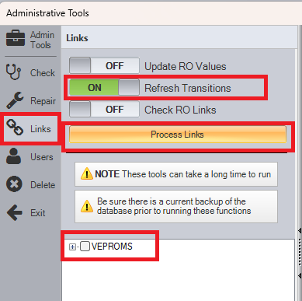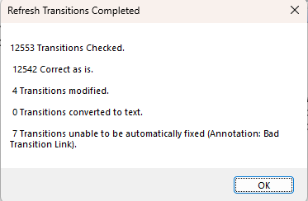

- Searching by Annotation Type for Bad Transition Link should then produce the annotations
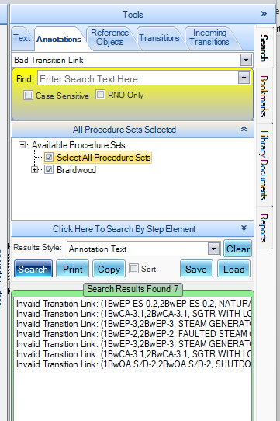

Changes/Additions to PROMS Manual and Training Videos:
[Do not use this section – for MRV/DMJ use]
- CSM submitted for PROMS User Manual: ____________.
- CSM submitted for training videos: ____________.

