March 16, 2026

Applicability: All plants

Internal Release Information:
B2026-022
Ensure that all symbols in the RO Editor and PROMS display in RO tables.
- [Check this box if a sql query or a data fix applies to this update].

Generic External Release:
RO Editor users can now insert symbols into individual RO information fields.

Plant Specific Information for Release Letter:
N/A

Testing Requirements:
Verify that symbols can be added to RO Tables in the RO Editor. That those RO tables can be added to a RO table step and also be printed with the symbols intact.
- Use Calaway database.
- Find and choose an RO table to test with.
- Add symbols to the table template.
- Save changes and verify the changes were saved correctly.
- Create new RO.FST.
- Import RO changes into PROMS.
- Add the changed RO to a RO step.
- Verify that the RO table contains symbols.
- Print the procedure or section to verify that the symbols print.

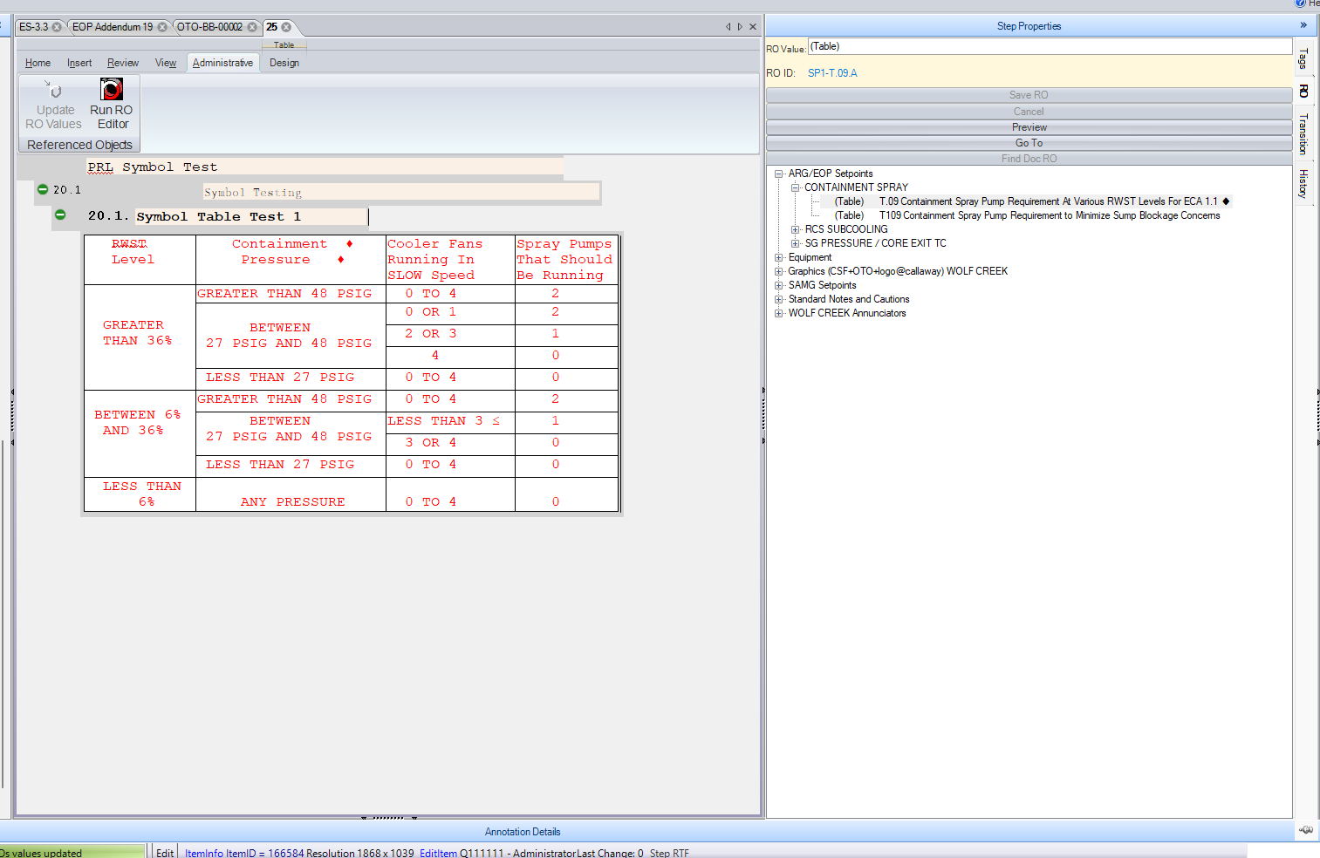

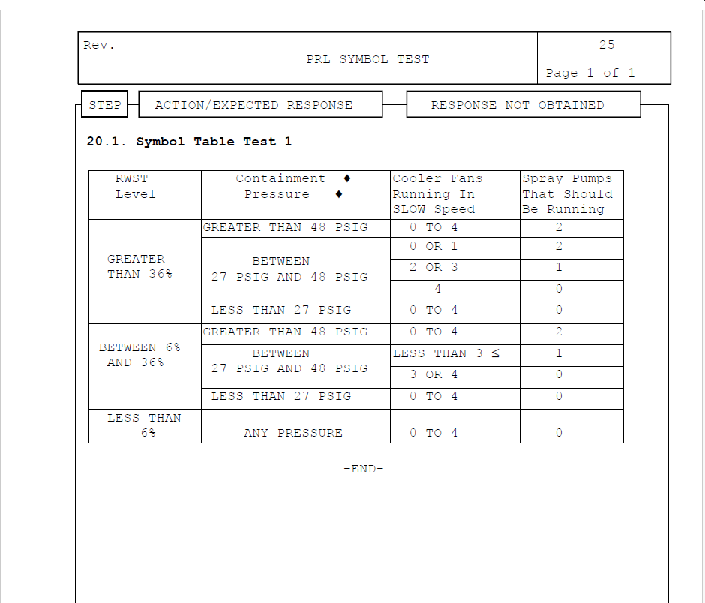

Changes/Additions to PROMS Manual and Training Videos:
[Do not use this section – for MRV/DMJ use]
- CSM submitted for PROMS User Manual: ____________.
- CSM submitted for training videos: ____________.

