March 16, 2026 (mv updated for testing Mar 18 2026)

Applicability: All plants

Internal Release Information:
B2026-022
Ensure that all symbols in the RO Editor and PROMS display in RO tables.

- [Check this box if a sql query or a data fix applies to this update].

Generic External Release:
RO Editor users can now insert symbols into individual RO information fields.

Plant Specific Information for Release Letter:
N/A

Testing Requirements:
Verify that symbols can be added to RO Tables in the RO Editor. That those RO tables can be added to a RO table step and also be printed with the symbols intact.

- Use the Callaway database. An RO table can be found in the first setpoint group in the Containment Spray subgroup.
- Add symbols into the table.
- Save the changes and verify the symbols appear in the table correctly.
- Create a new RO.FST and then update RO Values.
- Add the RO table into a procedure step.
- Verify that the RO table contains the symbols and they appear correctly.
- Print the table and verify that the symbols print correctly.

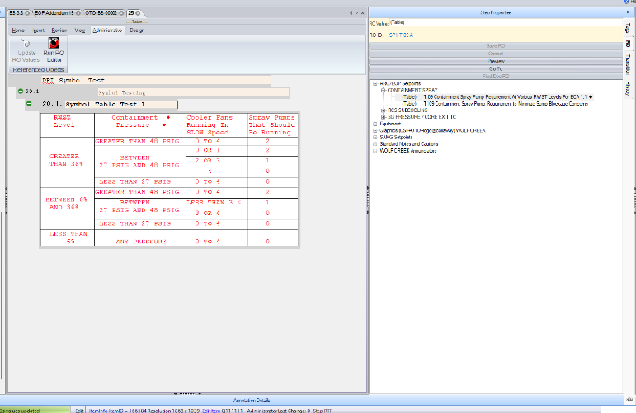

Changes/Additions to PROMS Manual and Training Videos:
[Do not use this section – for MRV/DMJ use]
- CSM submitted for PROMS User Manual: ____________.
- CSM submitted for training videos: ____________.

