September 4, 2025

Applicability: GEN

Internal Release Information:
C2024-036 Add Filtering ability to the main PROMS procedure tree.

Typing a procedure number or title into the search box and pressing enter/clicking the tree view search button will down base the PROMS procedure tree to matching procedures/folders.

- [Check this box if a sql query or a data fix applies to this update].

Generic External Release:
Added a feature to be able to filter the main PROMS procedure tree by typing a procedure number or title into the search box and pressing enter/clicking the filter button which will down base the PROMS procedure tree to matching procedures/folders.

Plant Specific Information for Release Letter:
N/A

Testing Requirements:
- Use Any DB
- Filter box should be shown both in Debug Mode and not in debug mode
  - In Debug Mode:
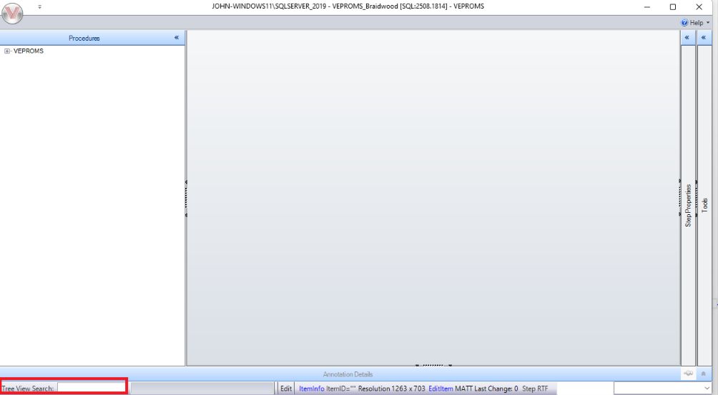
  - Not In Debug Mode:
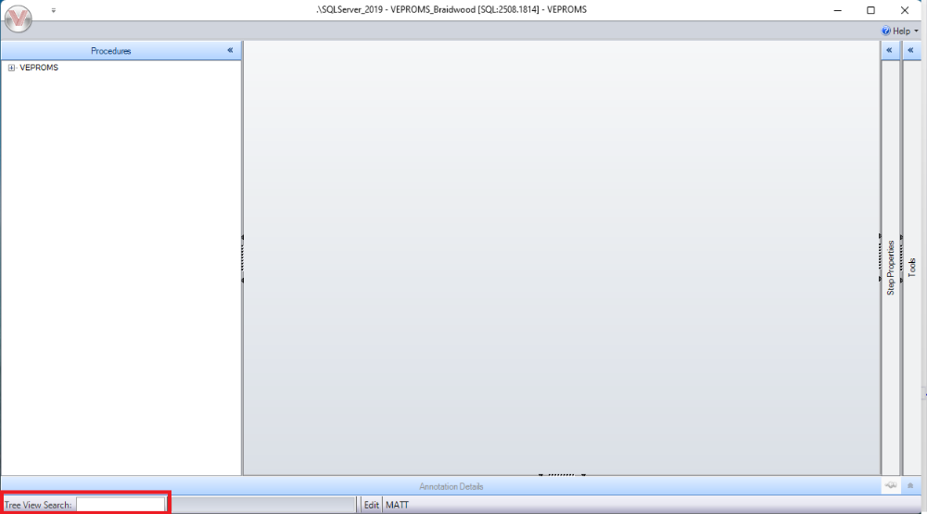
- Entering text in the box and pressing enter (or clicking the search button) should filter the PROMS tree to procedures / folders with procedure numbers or titles that contain the text.
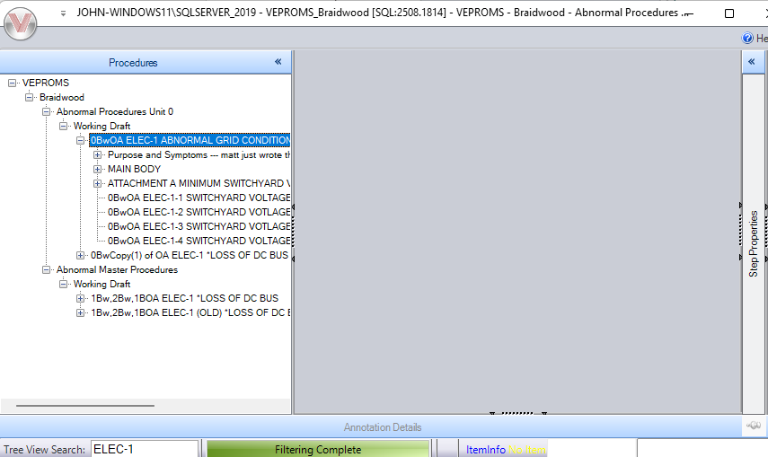

- After filtering, it should select the 1st “found” item in the PROMS Tree View so that pressing Enter would open the item.

Changes/Additions to PROMS Manual and Training Videos:
[Do not use this section – for MRV/DMJ use]
- CSM submitted for PROMS User Manual: ____________.
- CSM submitted for training videos: ____________.

