PROMS Print Section

Print a Section instead of printing a whole Procedure has been added to PROMS.
Now the ability to print Section and Word Sections is now available.
Printing Sections can be accessed by right clicking on a Section and selecting “Print Section”.
The same steps are used to print a Word Section.

Date: 2/08/2024

Applicability: PROMS all users.

Internal Data Fixes: N/A

Internal Release:
C2024-002 Develop a way to print individual sections in PROMS.
Generic External Release:
Ability to print Sections by themselves has been added to PROMS. To access printing a section right click on the section name and select “Print Section”. Printing a Section works with Word sections also.
Plant Specific Information for Release Letter: N/A

Testing Requirements:
With each test do all these steps.
- Right click on the Section and select “Print Section”.
- Compare the printed Section data with what you see in PROMS.
- Make sure all the data in the PROMS Section is in the printout.

- Use database VEPROMS_Beaver_Valley
- Open folder AOP. Select Procedure 1.6.5 Shutdown LOCA. Right click on PROCEDURE and choose “Print Section”.
- In the same Procedure “1.6.5 Shutdown LOCA” “Cover Page”.
- In the same Procedure print a figure (diagram). “FIGURE 1 Unit 1 Fire Protection System Yard Loop”.
- In same Procedure print a figure (picture). “FIGURE 4 Isolation of Unit 1 and Unit 2 Spent Fuel Pool Cooling”
- Change to database VEPROMS_CP.
- Open folder ERG – Master. Open Procedure “EOS-0.3A, B Natural Circulation Cooldown with Steam Void In Vessel (With RVLIS)” (Contains ROs). Section “Attachment 1.A, Foldout For EOS-0.3A Continuous Action Steps”. Select Unit 1.
- In the same Procedure print “Procedure Steps” (two column print) Select Unit 1.
- In the same Procedure print “B. Applicability” (section that is in the middle of a print page). Make sure there is a header on the printout.

Changes/Additions to User Documentation:
Ability to print Sections by themselves has been added to PROMS. To access printing a section right click on the section name and select “Print Section”. Printing a Section works with Word sections also. 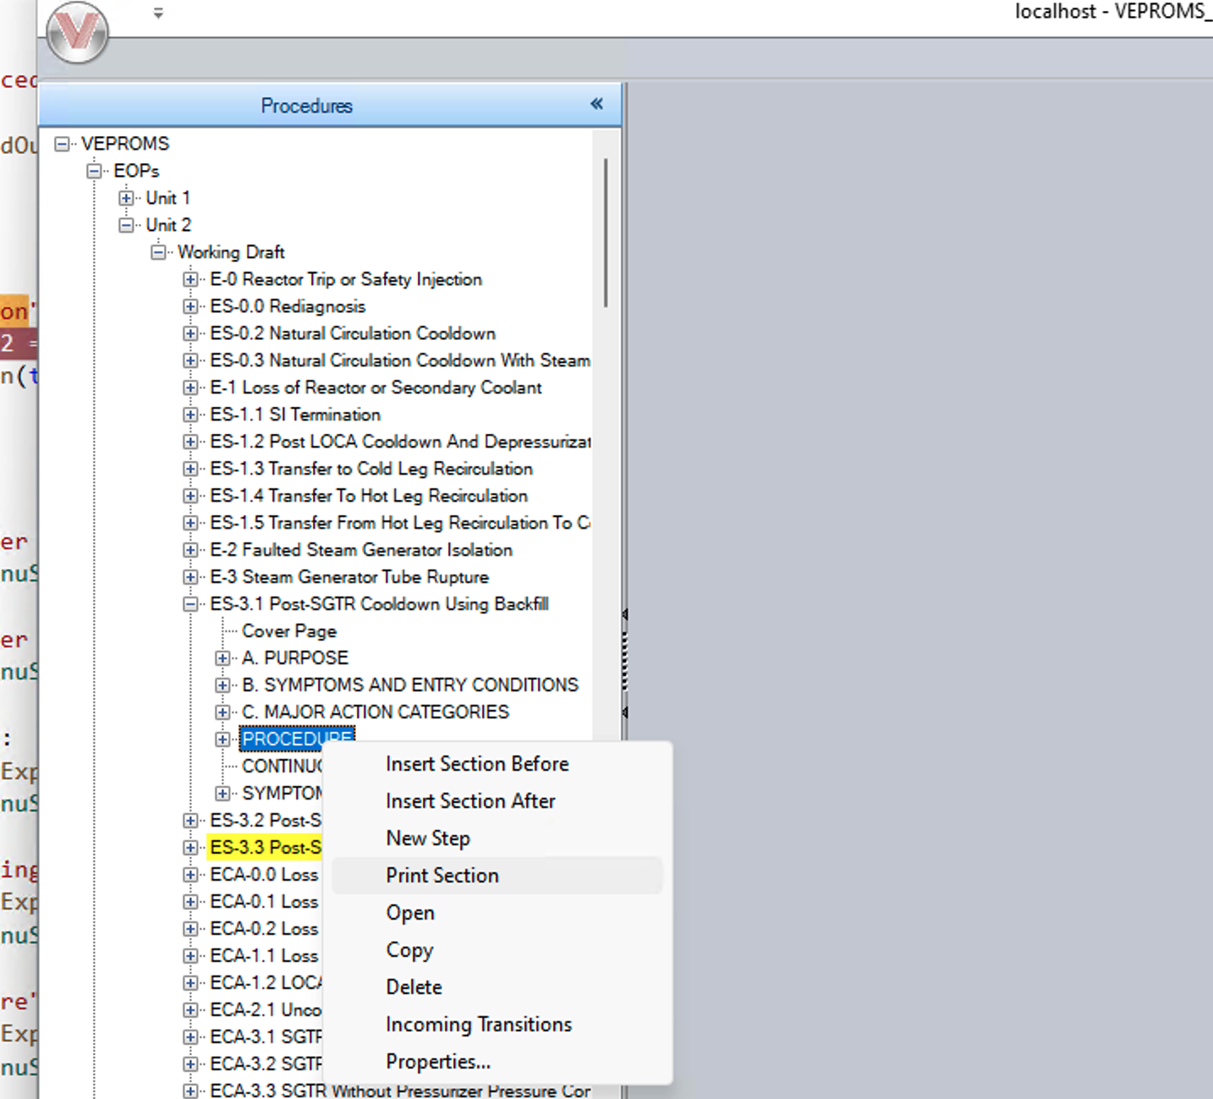
Word Section:


