June 5, 2025

Applicability: All plants

Internal Release Information:
B2025-034
Added code to catch EDWord error. EDWord is used to display Word Documents in PROMS. If EDWord is not installed PROMS crashes. The code update will inform the user that EDWord is not installed.

Generic External Release:
The user will be informed if EDWord is not installed and give them directions on how to install the it.

Plant Specific Information for Release Letter:
N/A

Testing Requirements:

You will be testing the new error handling if the EDWord supporting files are missing.
If the EDWord supporting files are missing, then no document can be opened in the PROMS editor.

- Use VEPROMS_BWD database.
- Open PROMS navigate to “Abnormal Master Procedures”.
- Open Procedure: “1Bw,2BwOA PRI-5 CONTROL ROOM INACCESSIBILITY”.
- Select “2BwOA PRI-F:5 OPERATOR ACTION SUMMARY FOR 2BOA PRI-5” Word Doc.
- Verify that the Word Doc gets displayed in PROMS Editor.
- Close PROMS
- Remove EDWord from Registry by following the directions on the next line.
- Follow the unregister directions in text file “B2025-034_test_steps .txt”.
- Open PROMS again.
- Select “2BwOA PRI-F:5 OPERATOR ACTION SUMMARY FOR 2BOA PRI-5” Word Doc.
- Verify that an error message appears informing the user that EDWord needs to be installed.
- Close PROMS.
- Follow the register directions in text file “B2025-034_test_steps .txt”.
- Open PROMS again.
- Verify again that the Word Doc gets displayed in PROMS Editor.

Screen shots below.
- Screen shot when EDWord is installed.

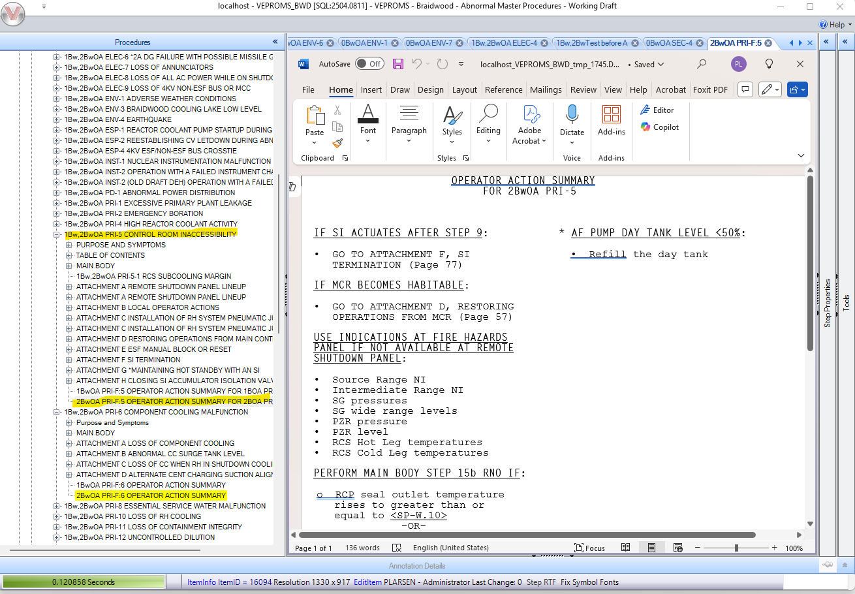

- Screen shot of error message:

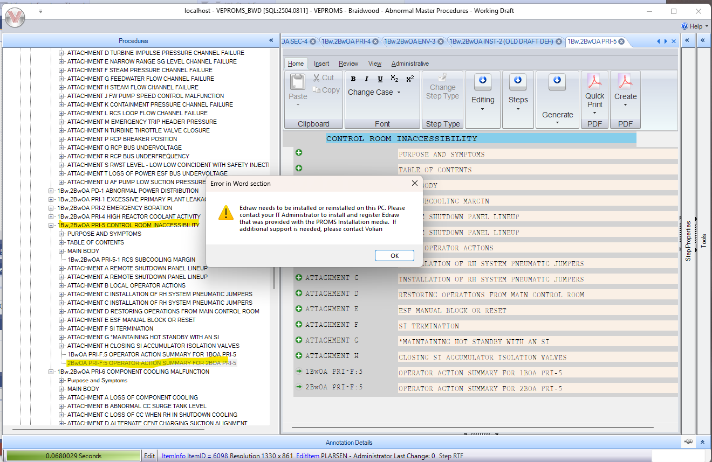

- Screen shot of PROMS editor after the error is closed.

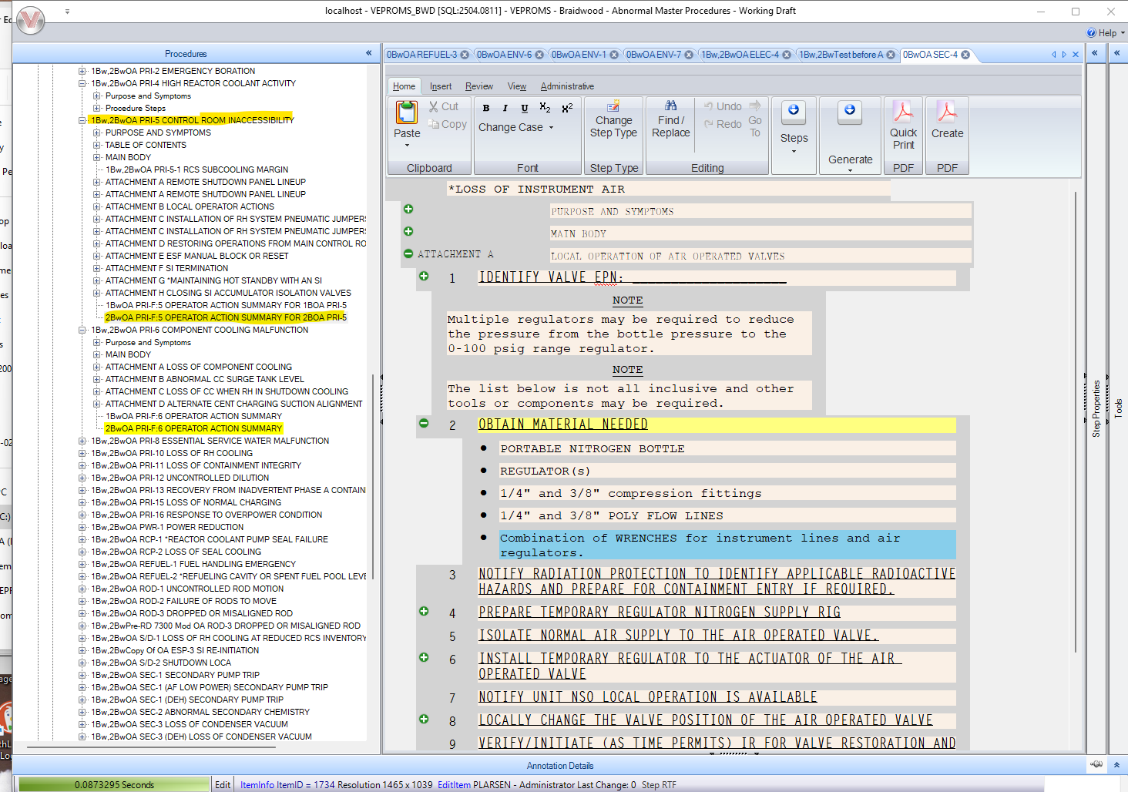

Changes/Additions to PROMS Manual and Training Videos:
[Do not use this section – for MRV/DMJ use]
- CSM submitted for PROMS User Manual: ____________.
- CSM submitted for training videos: ____________.

