February 27, 2024

Applicability: Vogtle Units 3 & 4

Internal Data Fixes: N/A

Internal Release:
F2024-026
Added a transition type that is just a section number in parentheses in the Vogtle Alarms format.

Generic External Release:
N/A

Plant Specific Information for Release Letter:
Vogtle Units 3 & 4
For the Alarms format, a transition type to a section that displays only the section number inside parentheses.

Testing Requirements:
Use Vogtle data
  - Update formats
  - Edit ZAS-ARP-016 step 3 in section 4.0 INSTRUCTIONS
  - In the table, replace the text “(Attachment1)” with the ({Section Number}) transition type

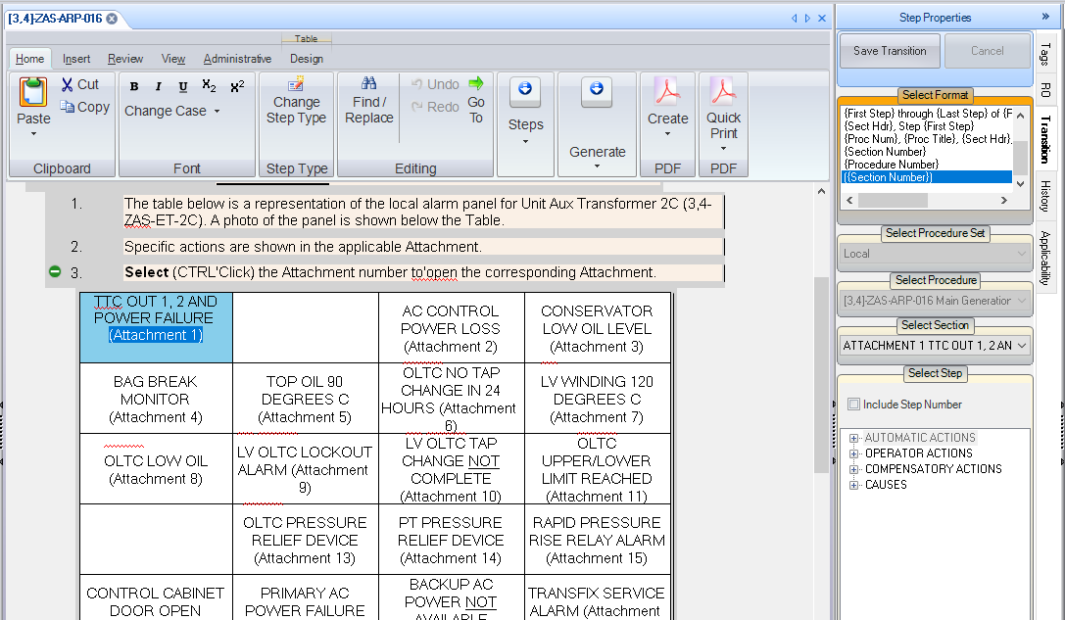

- Verify the transition displays the section number inside parentheses.

Changes/Additions to User Documentation:

N/A

