February 8, 2024

Applicability: Vogtle Units 3 & 4

Internal Data Fixes: N/A

Internal Release:
F2024-013
The end message for Attachment and Procedure Step sections is now bolded and have a dash before and after the end message

Generic External Release:
N/A

Plant Specific Information for Release Letter:
Vogtle Units 3 & 4
The end message for Attachment and Procedure Step sections is now bolded and have a dash before and after the end message

Testing Requirements:
Use Vogtle Unit 3 & 4 data
- Update formats
- Print Local Alarm Procedure ASS-ARP-010
- Verify the end message in the attachment sections are bold and had dashes like in the screenshot below.

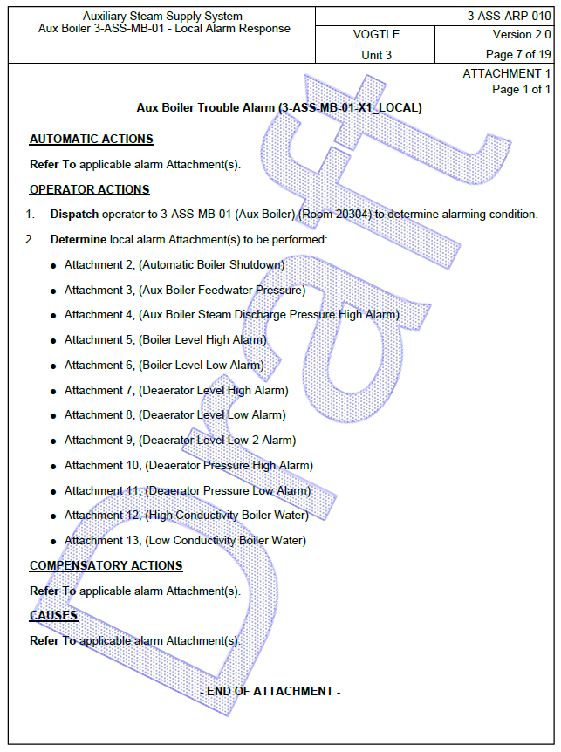

Changes/Additions to User Documentation:

N/A

