10/3/2024

Applicability: All plants

Internal Release Information:
C2020-049 Add the ability for PROMS to remember the procedure tabs that were open when you closed PROMS.

☒ [Check this box if a sql query or a data fix applies to this update].

Generic External Release: PROMS now remembers which procedures are open in the PROMS edit window and reopen them after the application is closed and re-opened. PROMS remembers the open procedures for every user.

Plant Specific Information for Release Letter: N/A

Testing Requirements:
- Use DB VEPROMS_PROMS_MANUAL.
- Open more than one procedure in the PROMS editor.
- Note which procedures you opened and the order they were opened.
- Close the PROMS application and then reopen it.
- Check the tabs to make sure that the same procedures are open and the order that they were originally open in.
- Close one procedure and open two or more other ones.
- Close the PROMS application and then reopen it.
- Check the tabs to make sure that the same procedures are open and the order that they were open in.
- Close the PROMS application and start the application under another user.
- You should see that there are no procedures open in the editor.
- Under the new user step through the above steps used for the first user.
- When finished testing the second user close the application and reopen it under the first user.
- You should see the editor in the same state you had left it when you tested with the first user.

PROMS screen shot with editor tabs highlighted.
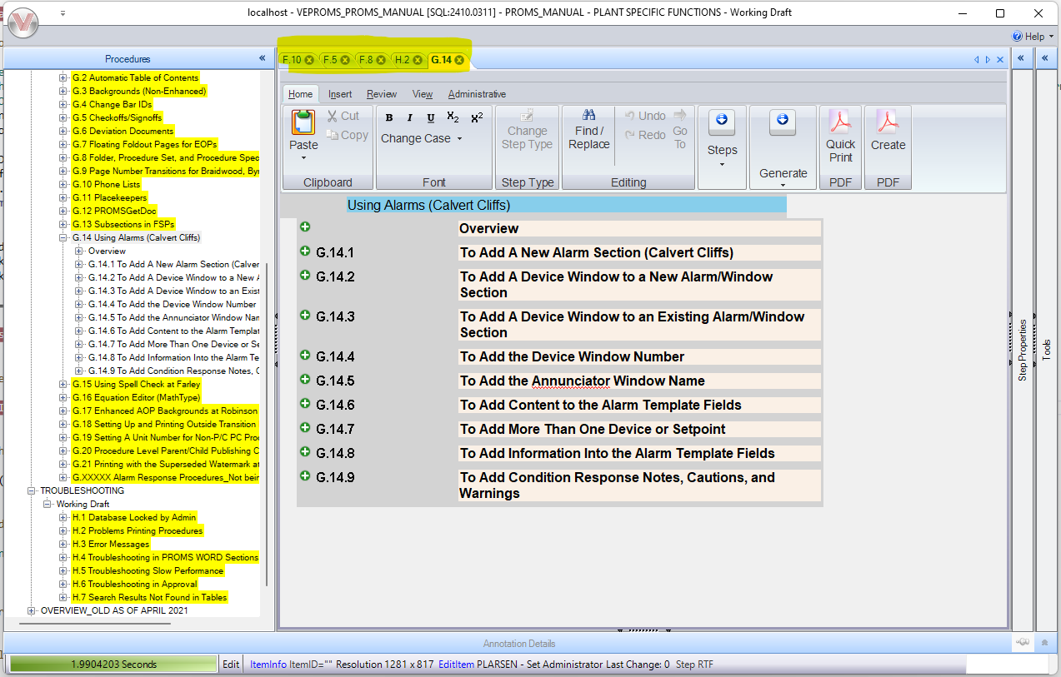

Changes/Additions to PROMS Manual and Training Videos:

- CSM submitted for PROMS User Manual: ____________.
- CSM submitted for training videos: ____________.

