5/22/2024

Applicability: B2024-023: Tree view and edit window not updated for enhanced section when new source section is created.

Internal Data Fixes: NA

Internal Release:

B2024-023: Tree view and edit window not updated for enhanced section when new source section is created. When inserting a source section, the associated enhanced section did not appear in tree view or in edit window (if it was displayed in editor). Add to tree view and close the enhanced procedure edit window. Note that closing of edit window was done to be consistent with what happens upon delete of source w/ and enhanced section.

Generic External Release:

When a section is created, the tree view and edit window are not updated for an associated enhanced section. The edit window of the associated enhanced will be closed after the section creation.
Plant Specific Information for Release Letter: NA

Testing Performed:

See Testing Required.

Testing Requirements:

Using Braidwood sql database:
£ Expand in tree view & edit a procedure and its associated enhanced procedure, such as Upgraded SAMGs/SAG-3 & associated Background document
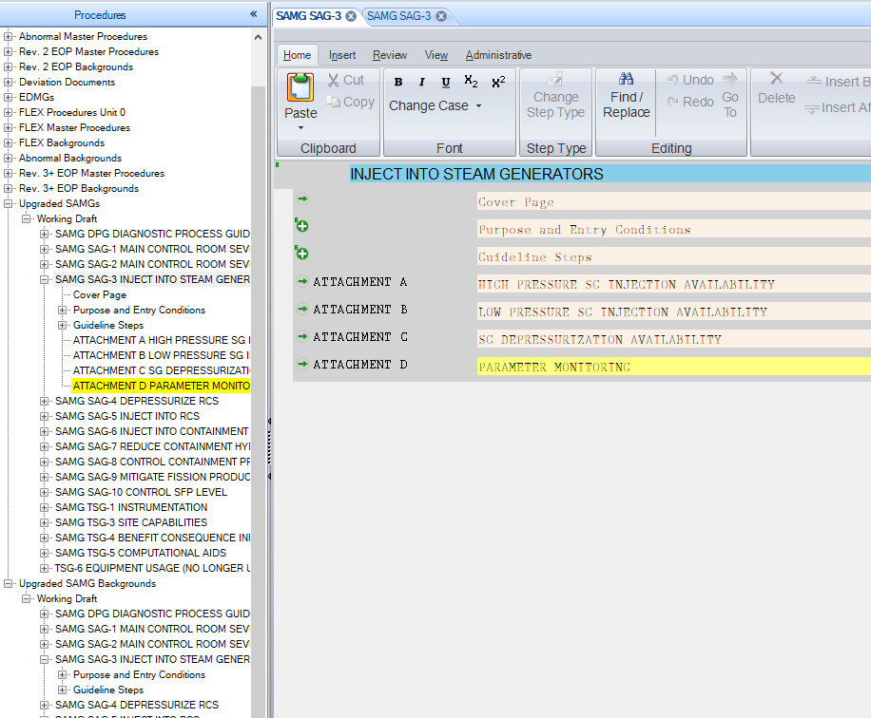
£ From the tree view, position on the SAG-3 source procedure/Guidelines Steps section
£ Using the context menu, select to Insert Section After. On the section dialog, verify that Automation/Link Enhanced ‘Contents’ is selected (it should be) and then select OK to create the section.
£ Verify that the new selection is in the tree view within the Upgraded SAMGS AND the Upgraded SAMG Backgrounds tree and that the edit window for the background has been closed:

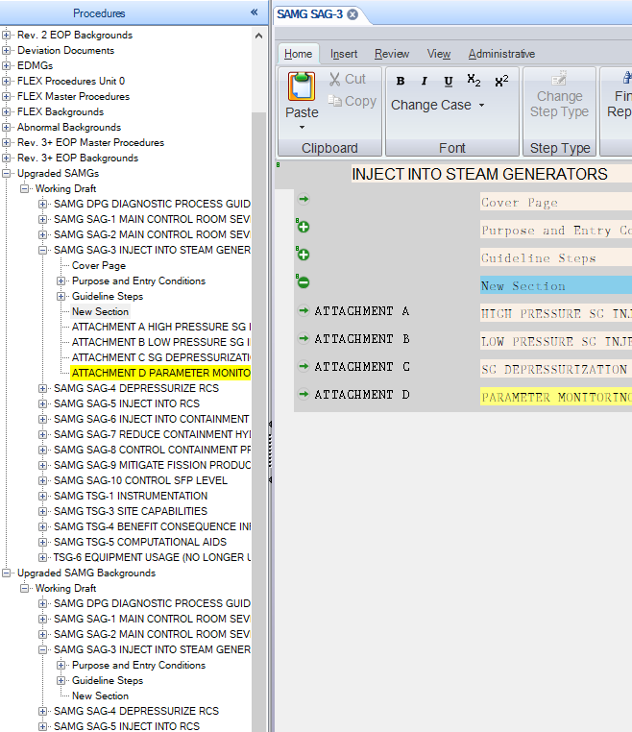

Changes/Additions to User Documentation:

Update Enhanced documentation if there are specifics on inserting of a new section.

