April 28, 2026

Applicability: All Plants

Internal Release Information:
C2026-027 & C2026-028
The “Set_At_All_Level” button on the Applicability tab is disabled if user is on a RNO step.

- [Check this box if a sql query or a data fix applies to this update].

Generic External Release:
The “Set_At_All_Level” button on the Applicability tab is disabled if user is on a RNO step.

Plant Specific Information for Release Letter:
N/A

Testing Requirements:
The test is to verify that the “Set_At_All_Level” button on the Applicability tab is disabled if user is on a RNO step. Verify the wording in the tool tip for the “Set_At_All_Level”

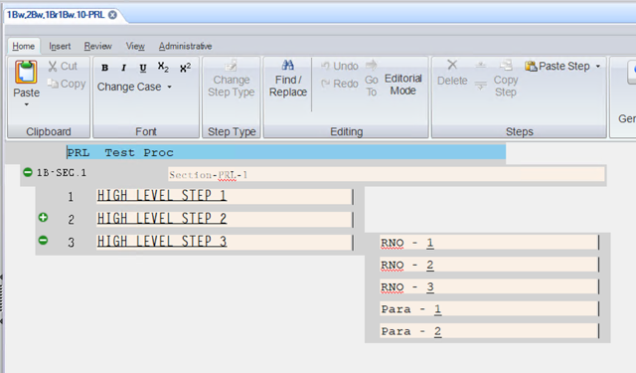

- Use VEPROMS_BWD DB.
- Create a test procedure with 3 high-level steps.
- Under one of the high level steps, add a substep.
- Off of the AER substep, add a RNO step.
- Add multiple substeps off of the RNO step.
- On one of the high level steps, insert an RNO.
- Add additional RNOs from the high level RNO step.

Testing
- Click in one of the AER high-level steps and select the Applicability tab on the Step Properties panel.
- Check each high-level step and RNO step to make sure that they are all set to the same setting.
- Change the applicability of a high-level AER, then click the “Set All At Level” button.
- Verify the high level AER steps now have the new applicability set.
- Select one of the RNO high level steps.
- Make sure the “Set All At Level” button is disabled.
- Select one of the RNO substeps and change the applicability, then click the “Set All At Level” button.
- Verify the applicability has been updated for each of the RNO substeps at the same level.
- Review the “Set All At Level” button tool tip text to make sure the reading is correct.

Changes/Additions to PROMS Manual and Training Videos:
[Do not use this section – for MRV/DMJ use]
- CSM submitted for PROMS User Manual: ____________.
- CSM submitted for training videos: ____________.

