March 6, 2024

Applicability: Vogtle Units 3 & 4 Alarms

Internal Data Fixes: N/A

Internal Release:
F2024-027
Added logic to include HLS text in the top continue message based on where the steps break.

F2024-028
Will now include the period after the sub-step number when used in the top continue message

Generic External Release:
N/A

Plant Specific Information for Release Letter:
Vogtle Units 3 & 4
Alarm format
Added Continue messages to the Attachment - Step Editor section style

Testing Requirements:
Use Vogtle data
- Update formats
- Print local alarm procedure DWS-ARP-010.
- View Attachment 1 page two and verify the top continue message has a period after the step number

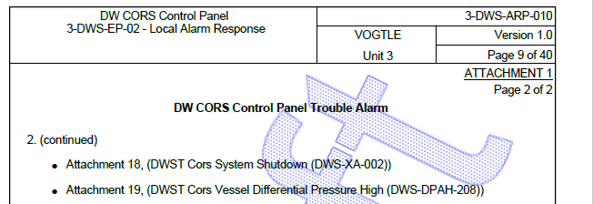

- View Attachment 9 page 2 and verify the top continue message include “OPERATOR ACTIONS”

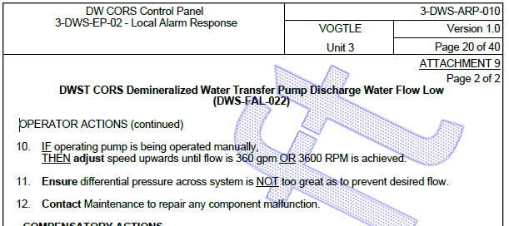

- Print local alarm procedure ZOS-ARP-011
- View Attachment 21 page 3 and verify the top continue message only and “(continued)”

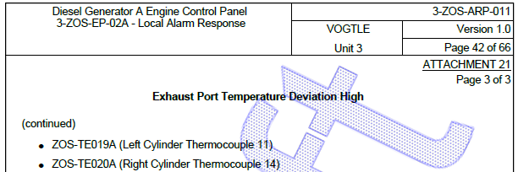

Changes/Additions to User Documentation:

N/A

