Applicability: Byron and Braidwood

Internal Data Fixes: N/A

Internal Release:
B2023-097
B2023-098
Baseline testing found that figures were shifted to the left. This was due to logic originally added for Barakah to adjust the white space around figures in which the size was adjusted when printing, but then, later, it was found that his broke the printing of figures for Wolf Creek. So that logic was encapsulated with a format flag and that format flag was only set in the Barakah formats. Turning this format flag on for the Byron and Braidwood formats allows their figures to print as it did with their prior PROMS release.

Generic External Release:

N/A

Plant Specific Information for Release Letter:

N/A – Byron and Braidwood’s current PROMS version does not have this found issue.

Testing Requirements:
- Use Braidwood data
- Update Formats
- Print procedure (for unit 1) 1BwEP ES-01in the Rev 3+ Master Procedures set
- Verify step 1, substeps a & b fit on the same page

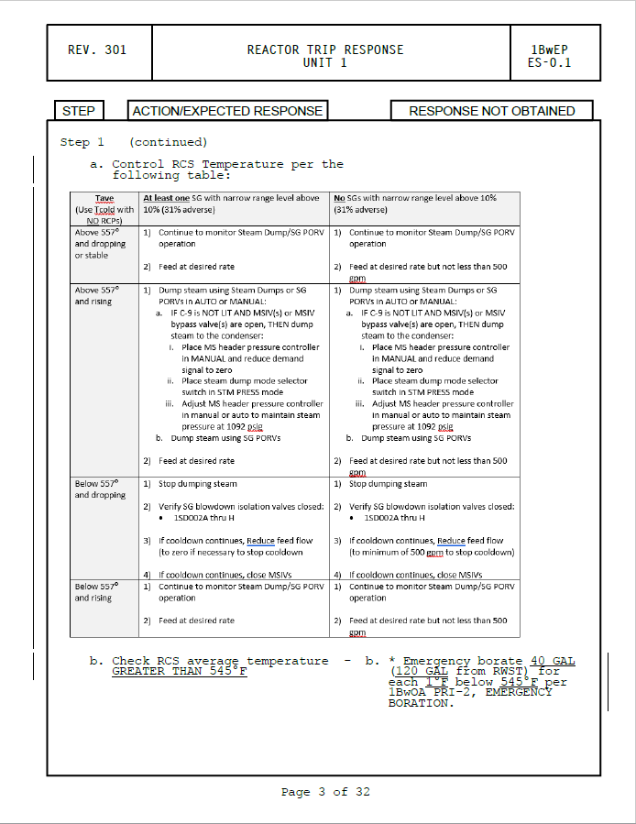

- Use Byron data
- Update Formats
- Print (for unit 1) procedure 1/2BOA TG-9 in the Abnormal Master procedure set
- Verify the figure in Attachment A prints as in the screenshot below

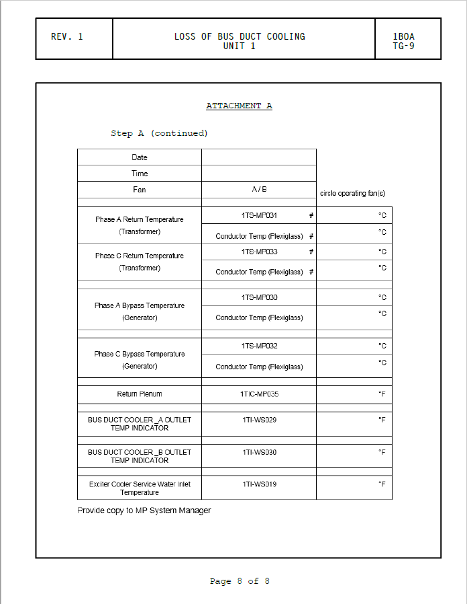

Changes/Additions to User Documentation:

N/A

