January 24, 2025

Applicability: All Plants

Internal Release Information:
B2025-005 PROMS - Change Reports - Invalid Transitions showing Incorrectly

When a transition has become a question mark in the step editor, the question mark displayed as a large solid bullet in the Summary and Chronology of Change Reports. This change is to have this currently display as a question mark as it does in the edit window.

- [Check this box if a sql query or a data fix applies to this update].

Generic External Release:
Updated Summary and Chronology of Change Reports to more clearly show when a step has an invalid transition.

Plant Specific Information for Release Letter:
N/A

Testing Requirements:
- This was found in Michelle’s ACME data while verifying information on reports.
- Go to a step where the transition has changed to a ?
For example:
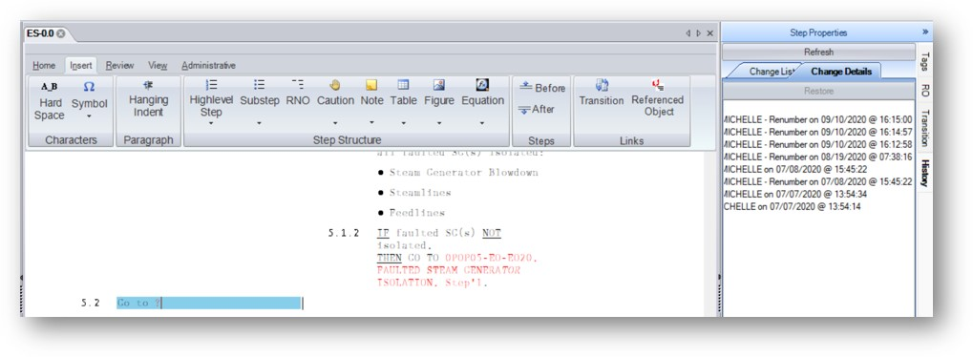
- Run both the Chronology Report and the Summary Report
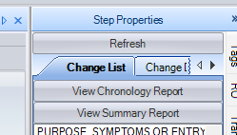
- On both reports, the Step text should show as “Go To ?”
For example:
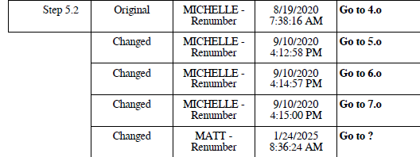

Changes/Additions to PROMS Manual and Training Videos:
[Do not use this section – for MRV/DMJ use]
- CSM submitted for PROMS User Manual: ____________.
- CSM submitted for training videos: ____________.

