December 10, 2025

Applicability: GEN

Internal Release Information:

C2025-060 When format is updated in PROMS, auto-update the format cache so it doesn't require exiting PROMS and going back in.

- [Check this box if a sql query or a data fix applies to this update].

Generic External Release:
When a format is updated in PROMS via V button->Administration->Update Formats, it will now auto-update the format cache so it doesn't require exiting PROMS and going back in.

Plant Specific Information for Release Letter:
N/A

Testing Requirements:
- use DB for Braidwood
- Open a procedure that uses CWE (like Abnormal Procedures Unit 0 -> 0BwOA ELEC-1)
- When printing, you will notice at bottom of Page 2, Page 2 of …
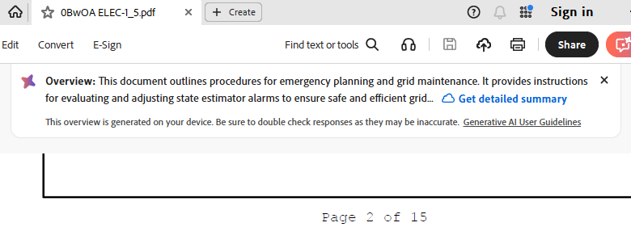

- Use the V button->Admin->Update formats
Update to the formats located at:
V:\Proms Versions\Test Version\Data to use for testing\ C2025-060
(After this, do not close PROMS until done testing as these steps should be done in conjunction to make sure that the cache is refreshed)
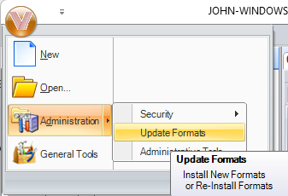

- Printing should use the new format file.
You will be able to tell this as the word “test” will be added to the page footer for Procedure Steps
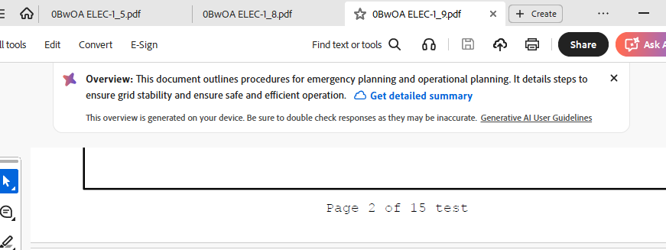

Changes/Additions to PROMS Manual and Training Videos:
[Do not use this section – for MRV/DMJ use]
- CSM submitted for PROMS User Manual: ____________.
- CSM submitted for training videos: ____________.

