October 22, 2025

Applicability: GEN

Internal Release Information:

B2025-056 Incoming Transitions Go To Procedure

When clicking on an incoming transition in the results panel, after deleting a procedure, PROMS no longer takes you to that location in the editor.

When this was originally designed, clicking on an incoming transition in the results would take the user to that specific location in the PROMS editor.

Michelle also found that if you go to “Incoming Transitions” without first opening a procedure, that the Convert Buttons will be greyed out.

- [Check this box if a sql query or a data fix applies to this update].

Generic External Release:
Modified “Incoming Transitions” so that clicking on a procedure will take you to that procedure.:

Plant Specific Information for Release Letter:
N/A

Testing Requirements:
- Use Any DB – pick a user with administrative rights
- Right click on a procedure in the Procedure tree and select “Incoming Transitions” (do not first open any procedure)
- If Incoming Transitions exist, then the “Convert All To Text” button should be enabled and (convert the transition to text and add an annotation).
- If Incoming Transitions exist and at least one is selected, then the “Convert Selected To Text” button should be enabled and work (convert the transition to text and add an annotation).
- Attempt to delete a procedure that contains transitions that are going to it from a different procedure – this will popup the message below and also show the Incoming Transitions:
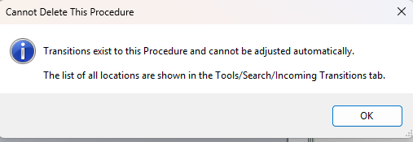

- You can also right click on a procedure in the Procedure tree and select “Incoming Transitions”
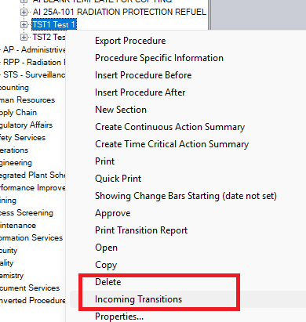
- Clicking on an item in the search results box, should open and go to the step that transitions to this location. 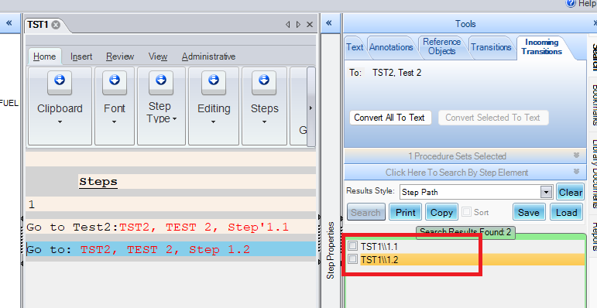

Changes/Additions to PROMS Manual and Training Videos:
[Do not use this section – for MRV/DMJ use]
- CSM submitted for PROMS User Manual: ____________.
- CSM submitted for training videos: ____________.

