May 28, 2025

Applicability: All Plants

Internal Release Information:
B2025-024
Added Child (unit) Applicability for Print and Quick Print for Word Documents.

Generic External Release:
Child (unit) Applicability has been added to Word Documents “Print Section” and “Quick Print Section” in the menu selections.

Plant Specific Information for Release Letter:
N/A

Testing Requirements:
- Use any DB that has multiple units (parent / child).
- Open PROMS and navigate to a Word Document section.
- Right click on the item in the Tree view on the left.
- Verify that the two Print options appear. “Print Section” and “Quick Print Section”.
- Hover over each one to make sure the Child (units) appear.
- Test printing of both “Print Section” and “Quick Print Section” options.
- Make sure both selections print correctly.

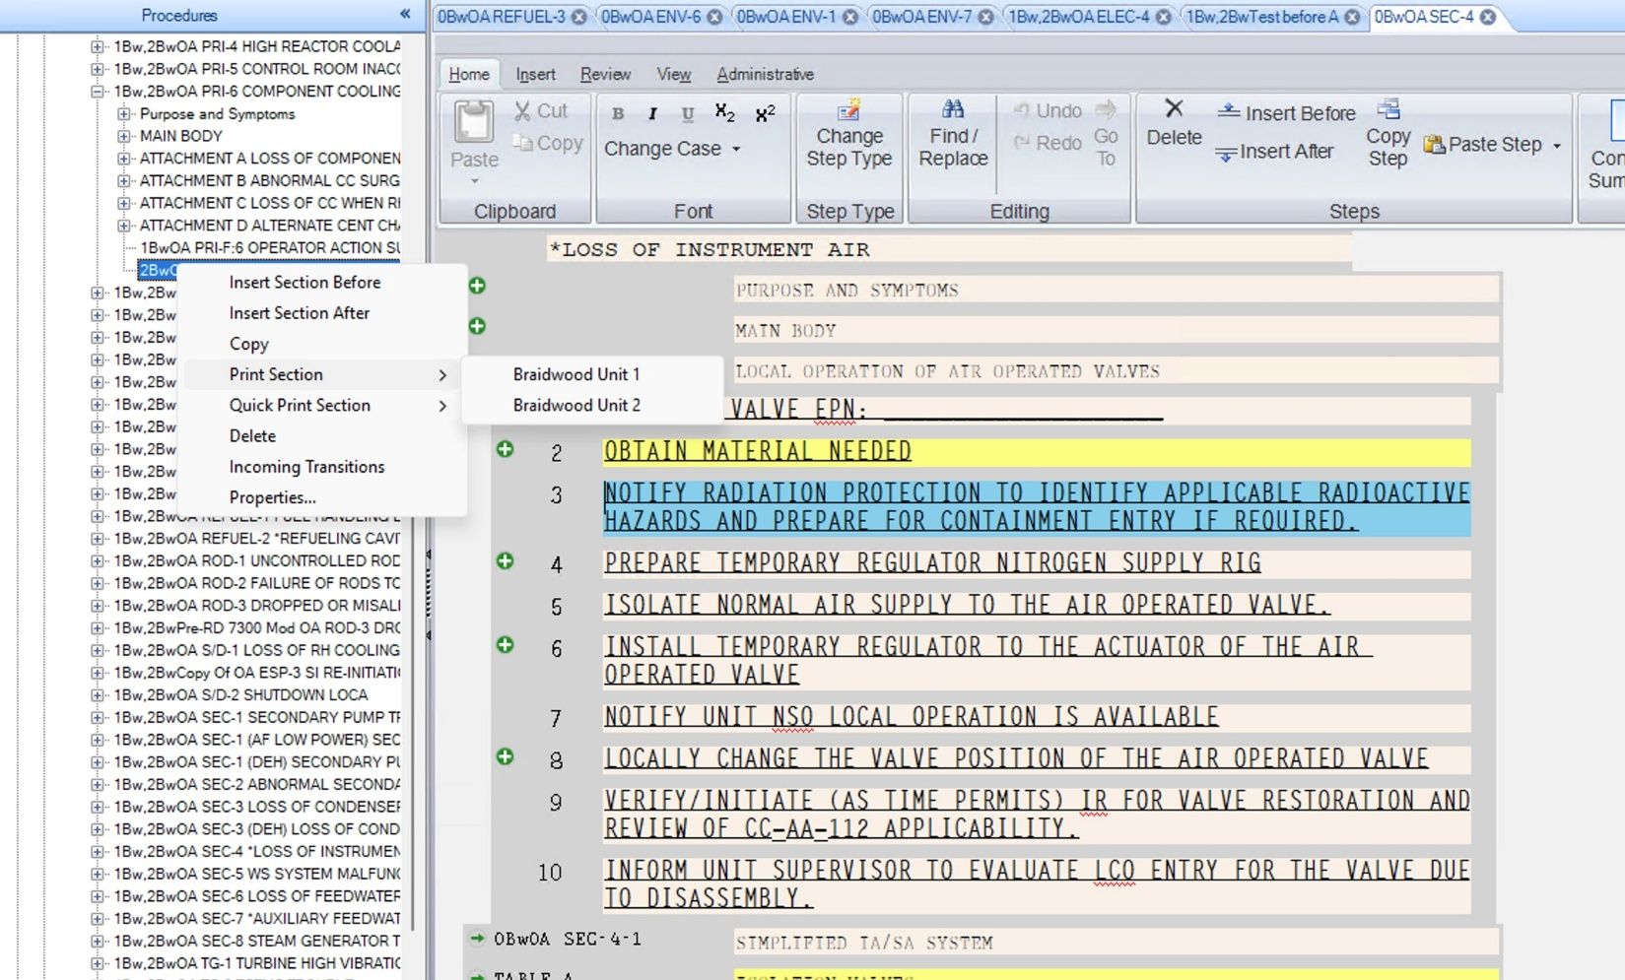

Changes/Additions to PROMS Manual and Training Videos:
[Do not use this section – for MRV/DMJ use]
- CSM submitted for PROMS User Manual: ____________.
- CSM submitted for training videos: ____________.

