January 19, 2026

Applicability: GEN

Internal Release Information:

C2026-002 Admin Tool - Data Check - Enhancements to new admin Tool for ROs not used.

Add the ability to filter out groups of Alarms from the results.

- [Check this box if a sql query or a data fix applies to this update].

Generic External Release:
Added a method to ROs Not Used Snapshot to be able to filter out groups of ROs.

Plant Specific Information for Release Letter:
N/A

Testing Requirements:
- Use Any DB that has ROs (Administrative User)
- Open the V button->Administration->Administrative Tools
- Go to the Maintenance tab and click the button for “Generate Snapshot of ROs Not Used”
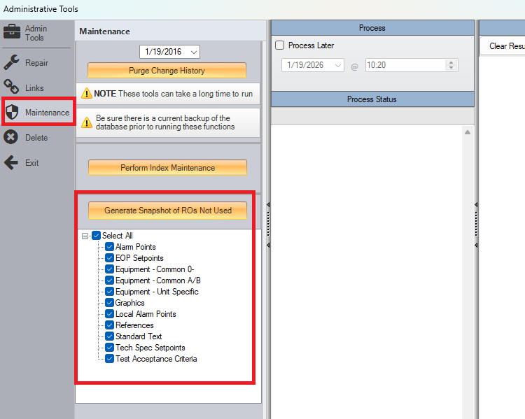
- Selecting or deselecting the RO groupings should result in ROs under those groupings being appropriately included or filtered from the snapshot depending on being selected.
- It should prompt for a filename / where to save the image and then begin generating.
- After done generating, it will prompt if you wish to open the image – if yes is selected, then image will open in the default image software for the computer.
- Image should show Folder level items --- for individual ROs, it should only show ROs not used in PROMS steps. It should take into account ROs used only in word sections. Image should be large enough to contain entire RO tree – for example:
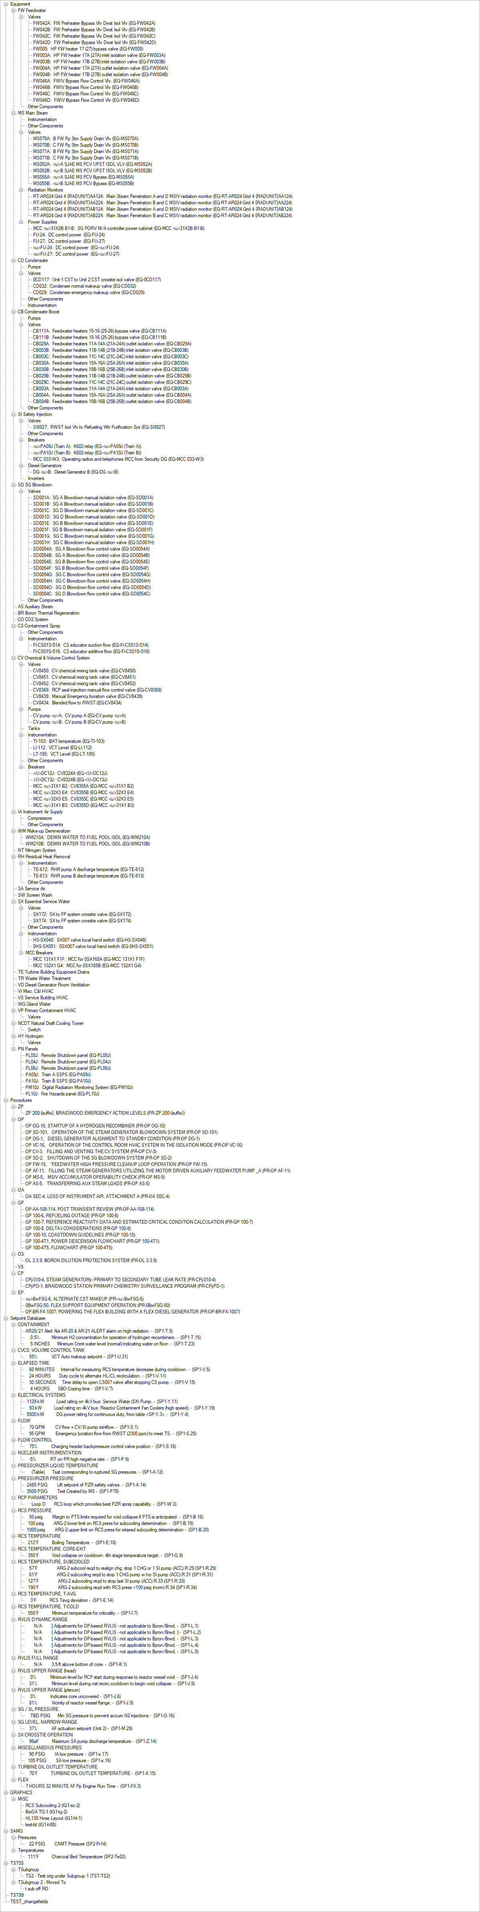

Changes/Additions to PROMS Manual and Training Videos:
[Do not use this section – for MRV/DMJ use]
- CSM submitted for PROMS User Manual: ____________.
- CSM submitted for training videos: ____________.

