January 21, 2026

Applicability: Vogtle Units 3&4

Internal Release Information:
C2026-003
For Vogtle Units 3&4, added format variable to allow a high level RNO step be “tagged” as a Continuous Action Step, when the parent AER step is not a continuous action step.

Format file settings:
Set ‘AddContActTagToHighLevelRNOWhenIncludedOnCAS’ to true in “StpSectLayData”
Set “CASPrintMacro” and “CASEditTag” on the RNO step type TabData definition to define the print macro and the indicator next to the RNO step number in the editor

- [Check this box if a sql query or a data fix applies to this update].

Generic External Release:
N/A

Plant Specific Information for Release Letter:
Vogtle Units 3 & 4
Vogtle Units 3 & 4 Two Column Format
PROMS will now draw the continuous action box around RNO steps, selected to be included on the Continuous Action Summary, when the procedure is printed.

Testing Requirements:
Use Vogtle Units 3 & 4 data
- Update formats
- Open AOP-302 to step 6 in the Operator Actions section
- Verify the RNO off of sub-step “a” has an ‘*’ next to it

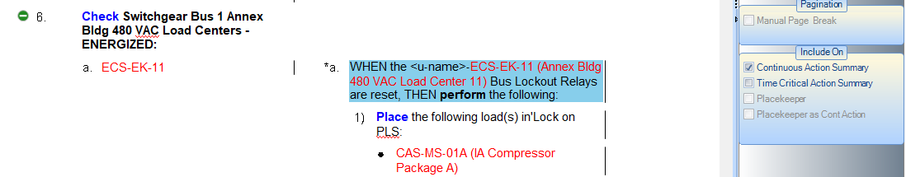

- Print the procedure and verify the RNO off of sub-step “a” has a box round it

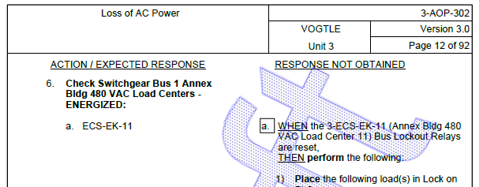

- Got back to the editor
- Click on the sub-step RNO “a” of step 6
- Open the Step Properties panel and select the “Tags” tab
- Uncheck the “Include on Continuous Action Summary” checkbox
- Verify the “*” is removed from the RNO step tab in the editor.
- Print again and verify it does not print a box around that RNO sub-step tab

Changes/Additions to PROMS Manual and Training Videos:
[Do not use this section – for MRV/DMJ use]
- CSM submitted for PROMS User Manual: ____________.
- CSM submitted for training videos: ____________.

