August 12, 2025

Applicability: Beaver Valley and Generic

Internal Release Information:
C2025-015
Added logic to make approved PDF names unique to allow procedures from different sets or different revs of the same procedure to be opened (viewed) at the same time. A partial folder path, the revision number, and if applicable, the child name is used to create the PDF file name to be viewed.

- [Check this box if a sql query or a data fix applies to this update].

Generic External Release:
PROMS now allows the user to view (open) multiple approved versions of a procedures at the same time, as well as approved versions of a procedures with the same procedure number from different procedure sets.

Plant Specific Information for Release Letter:
Beaver Valley
PROMS will now allow you to open an approved PDF from the Unit 1 procedure set and an approved PDF (with the same procedure number) form the Unit 2 procedure set – at the same time.

Testing Requirements:
Use Beaver Valley data
- Navigate to the Unit 1 EOP procedure set and open the last approved PDF file for procedure E-0

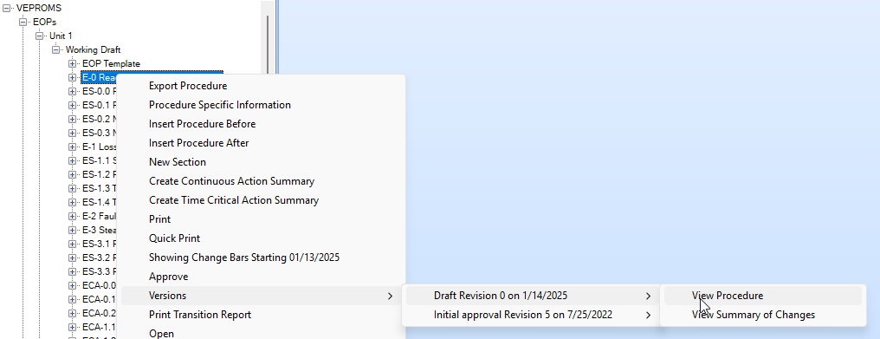

- Navigate to the Unit 2 EOP procedure set and open the last approved PDF file for procedure E-0
- Verify that both PDFs are open in the PDF viewer
- Hover over each tab in Adobe and verify that the file names include the folder and approved revision number

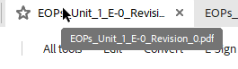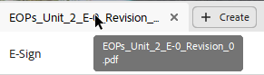

Use Braidwood data
- Navigate to the Rev.2 EOP Master procedure set and open the approved PDF file for procedure EP-0 Unit 1 and then open the Unit 2 approved PDF
- Verify that both PDFs are open at the same time in the PDF viewer

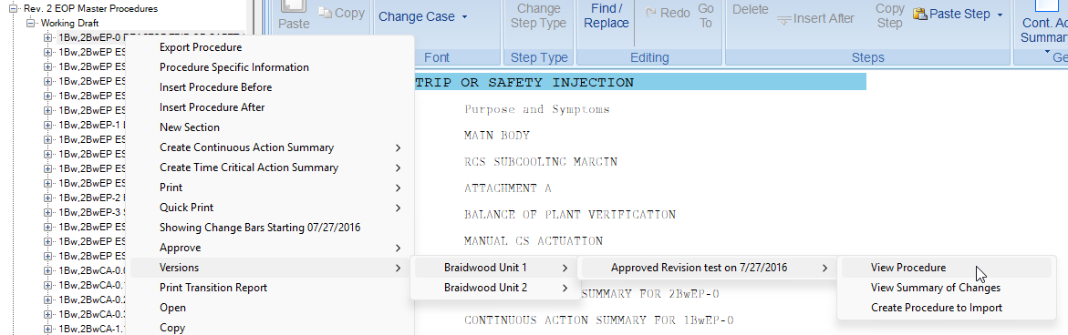

- Hover over each tab in Adobe and verify that the file names include the folder and approved revision number

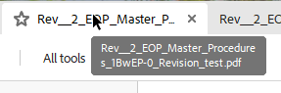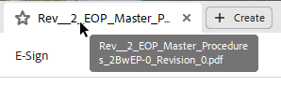

Use Prairie Island data
- Navigate to Instrument Failure Guldlines, Procedure (IFG.PRC) procedure set and open the approved PDF for the “1C51.1” PP HIGH procedure child and open the approved pdf for the “1C51.2” child procedure

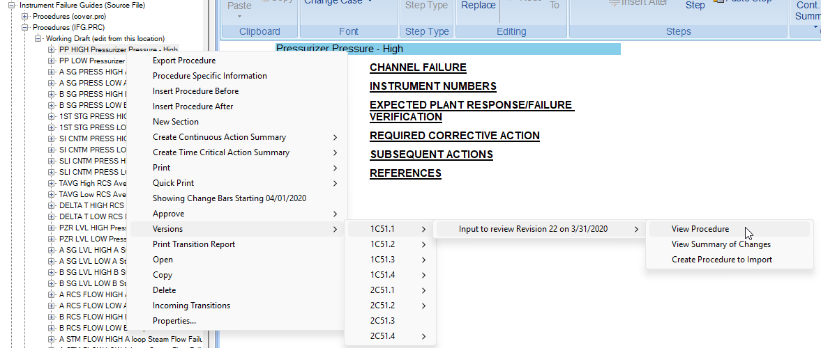

- Verify that both PDFs are open at the same time in the PDF viewer
- Hover over each tab in Adobe and verify that the file names include the folder and approved revision number

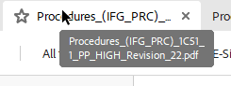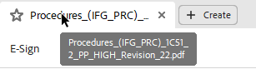

Changes/Additions to PROMS Manual and Training Videos:
[Do not use this section – for MRV/DMJ use]
- CSM submitted for PROMS User Manual: ____________.
- CSM submitted for training videos: ____________.

