January 9, 2026

Applicability: GEN

Internal Release Information:

C2025-043 Admin Tool - Data Check - Tool to identify and report RO's that are not used in any of the PROMS data.

- [Check this box if a sql query or a data fix applies to this update].

Generic External Release:
Added a method to Administrative Tools of generating a snapshot showing ROs that are not currently utilized in PROMS. This could be useful to identify and clean up old no longer used ROs as well as to identify if steps/RO usage in steps is missing.

Plant Specific Information for Release Letter:
N/A

Testing Requirements:
- Use Any DB that has ROs (Administrative User)
- Open the V button->Administration->Administrative Tools
- Go to the Maintenance tab and click the button for “Generate Snapshot of ROs Not Used”
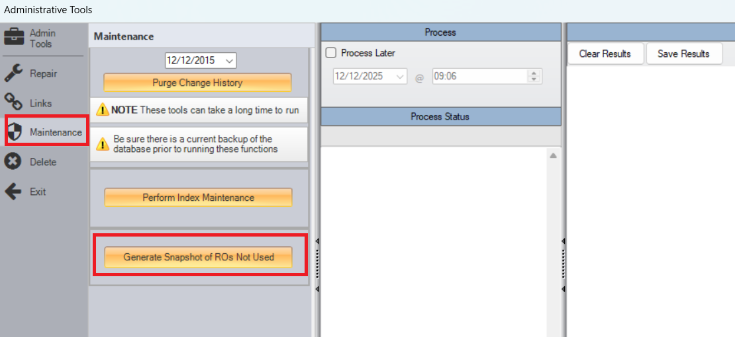
- It should prompt for a filename / where to save the image and then begin generating.
- After done generating, it will prompt if you wish to open the image – if yes is selected, then image will open in the default image software for the computer.
- Image should show Folder level items --- for individual ROs, it should only show ROs not used in PROMS steps. It should take into account ROs used only in word sections. Image should be large enough to contain entire RO tree – for example:
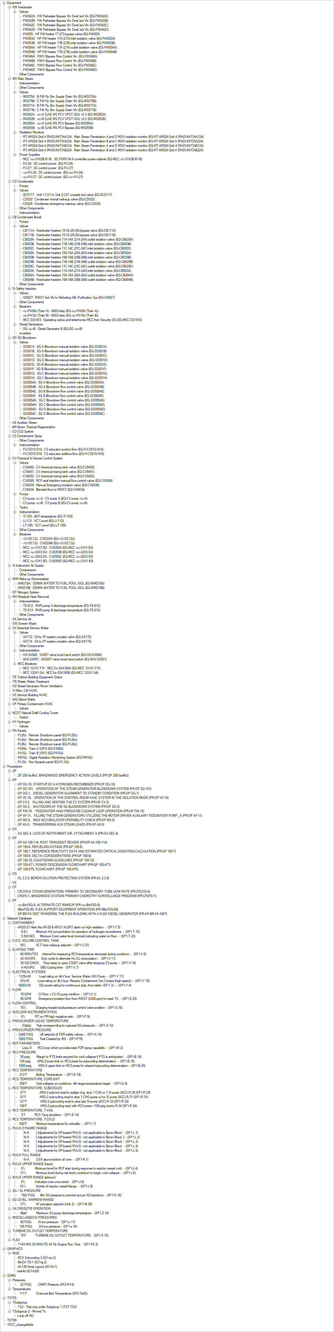

Changes/Additions to PROMS Manual and Training Videos:
[Do not use this section – for MRV/DMJ use]
- CSM submitted for PROMS User Manual: ____________.
- CSM submitted for training videos: ____________.

