Initial Setup (for EP use in any DB):
- Use any Plants DB
- Create a new Annotation Type to use as an EP Annotation Type
SELECT * FROM [AnnotationTypes]
--will be most recently created TypeID
- Create EP Format file in epall folder (example EPFortmatTST1.xml)
- Add reference in main format file to EP format file (and also reference to related annotation type). Example (EPTST1all.xml):
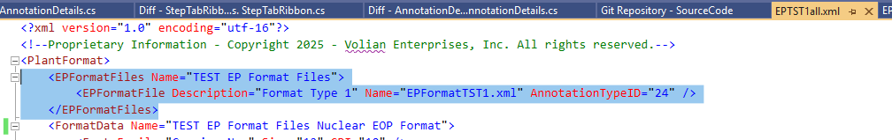
- Format must be in use when start PROMS (note: it basically checks for in use format files with the lines above and marks the referenced Annotation Types as being “Electronic Procedure Annotation Types”)
- Start PROMS and update / add new formats
- Note: It is recommended to do a full db backup before any changes are done to the Electronic Procedure xml file.

Setup/ Creation of EPFormat file:
- File will go in Formats\epall folder
- Example: (see EPFormatTST1.xml)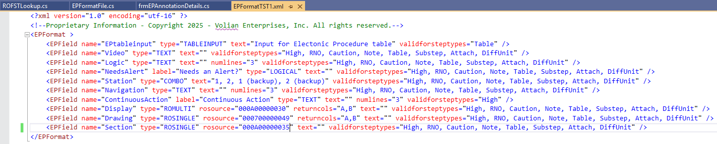

- Types of EPFields:
- TABLEINPUT – specifically for steptypes of table, allows user to specify which table cells will have EP input of (none,checkbox,textbox).
- TEXT - textbox
- LOGICAL - checkbox
- COMBO – dropdownlist where options are specified in EP Format file.
- ROSINGLE – dropdownlist attached to an RO Group where options are the individual ROs within that group
- ROMULTI – combobox attached to an RO Group where options are the individual ROs within that group (MULTI-SELECT version of ROSINGLE)

- EPField Properties:
- validforsteptypes - designates which types of steps the input should show for.
- label – label to use in UI attached to control, if not included, uses name of EPField.
- text – for COMBO – list of values (for example: text="1, 2, 1 (backup), 2 (backup)"). For LOGICAL – will add text next to checkbox.
- numlines – for TEXT – specifies number of lines a textbox should span by default. If not included, is a 1 line textbox.
- rosource – roid of group that you want ROSINGLE/ROMULTI to base off of
SELECT TOP 1 * FROM RofstChild
where title = 'ROGroupName' and value is null
- returncols – For ROSINGLE/ROMULTI - which ReturnValues you want to include when exporting to xml. If return value is a single value, then this field can be excluded. Otherwise. May specify something like
returncols="A,B"
for an RO with a return value of:
{{A=<ID>}{B=<Room>}{C=<Description>}}

Common troubleshooting (open button not showing on an EP Annotation):
- Were format files imported? / Re-import format files
Select * from Formats
Look at the Data Column for your format file – does it contain a reference to your EP File and Annotation Number?
- Does the step that the annotation is attached to use a format that contains a reference to an EP format file?
- Is the step that the annotation is attached to in the validforsteptypes of any EP Fields?

Common troubleshooting (slow loading of ROs / EP Annotations with ROs after adding and importing RO):
- Can run the following in SQL to rebuild one of the main indexes:
ALTER INDEX [IX_RofstID_DbiID_ParentID] ON [dbo].[RofstChild] REBUILD PARTITION = ALL WITH (PAD_INDEX = OFF, STATISTICS_NORECOMPUTE = OFF, SORT_IN_TEMPDB = OFF, ONLINE = OFF, ALLOW_ROW_LOCKS = ON, ALLOW_PAGE_LOCKS = ON)
GO

