November 17, 2025

Applicability: GEN

Internal Release Information:

C2019-036 View Only mode work with Checked Out Procedures

When a user is in "View Only" mode, they should be able to view checked out procedures (used to be B2019-142) Ask for by BNPP but is generic.

Added the ability for a user to open checked out procedures in view only mode as well as a method to refresh the view of a procedure in PROMS (without exiting and re-entering PROMS) and disabled the Step Properties tab while in “View Only Mode”.

- [Check this box if a sql query or a data fix applies to this update].

Generic External Release:
Added the ability for a user to open checked out procedures in view only mode as well as a method to refresh the view of a procedure in PROMS and disabled the Step Properties tab while in “View Only Mode”.

Plant Specific Information for Release Letter:
N/A

Testing Requirements:
- Use Any DB (will need to log in as 2 different users at the same time)
- Open a procedure with one user and then attempt to open the same procedure with the other user --- Should be prompted with a prompt similar to:
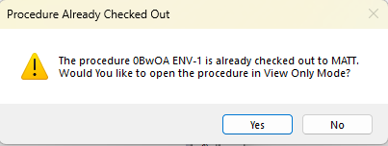
- Yes – should open in view only mode
- No – should not open
- Several variations of this need tested, for example:
- Opening the procedure for both users via clicking on the procedure in the tree.
- Opening the procedure for both users via going in with the Remember Tabs set and the same procedure being remembered.
  - For this for entering view only mode, should verify that cannot enter text while in view only mode and “View Only” is highlighted in the View tab of the Ribbon.
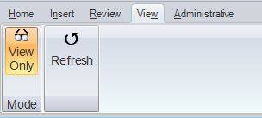
- Selecting a procedure in the Tree and using V -Open
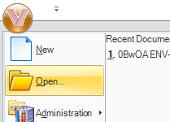
- Clicking Incoming Transitions and then Clicking on a procedure to open it. 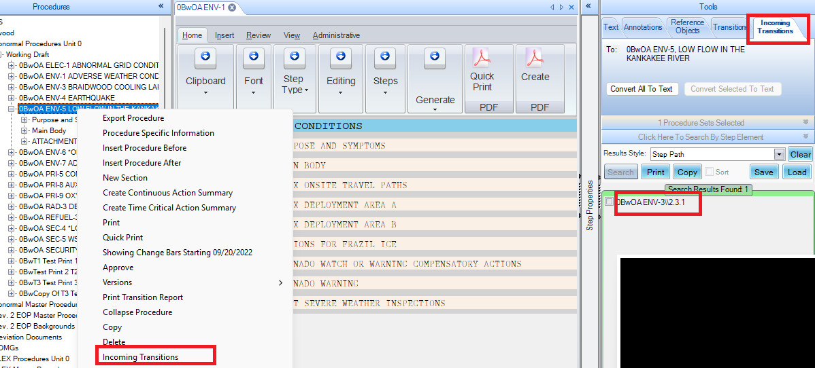
- Opening a procedure from Tools -> Search
- Opening a procedure for both users while utilizing the “Separate Windows” feature
- A user should not be able to leave View Only Mode while another user has the same procedure checked out:
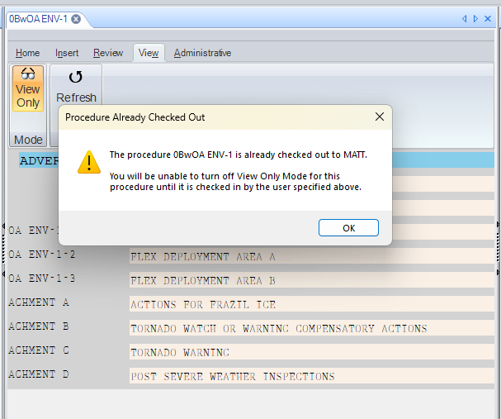
- If the other user checks in / closes the procedure or if the other user enables view only mode, then the first user should be able to leave view only mode.
- When in View Only Mode and clicking on a Step, the Step Properties tab should be disabled (i.e. items/tabs should not be selectable)
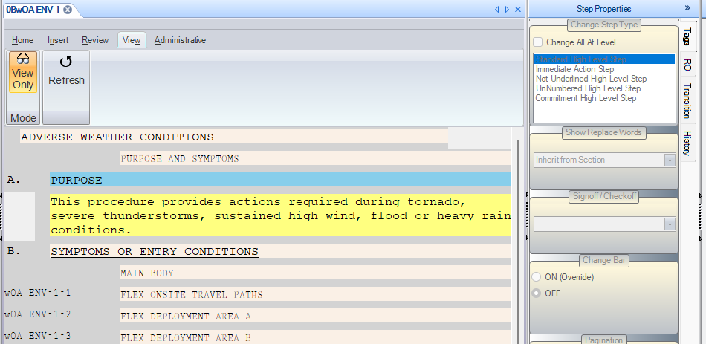
- Exiting “View Only Mode” should re-enable the step properties.
- In addition to normal selecting/deselecting “View Only Mode” via the ribbon, this also needs tested when a procedure starts in “View Only Mode” because of Remember Tabs.
- You should still not be able to select Properties on a Procedure when it is checked out.
- Selecting Properties on a Section of a checked-out procedure should still result in:
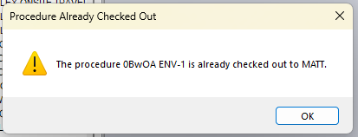
- Selecting Properties on a Working Draft Folder with a checked-out procedure should still result in:
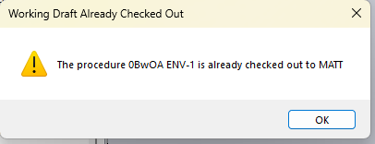
- You should also not be able to Approve a Procedure that is checked out by another user.

- When multiple Users have a procedure open in “View Only Mode” for more than a minute, the procedures should not automatically close. (this was a feature that I changed whereby procedures that were open but not checked out would auto close after a certain number of seconds).

- Open the same procedure with multiple users. Then with the user able to make changes, make some edits. After that, have the other user go to the View -> Refresh button in the ribbon. This should refresh their procedure with the added changes. It should not matter which steps / sub-steps are selected and their relation to where the changes are made in the procedure (i.e. if changes are made to the selected step, a step above it, or a step in the same procedure but a different section than the selected step or if changes are made to the procedure title)
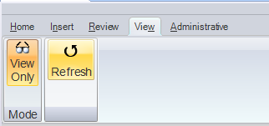
- When have multiple tabs open for the same user (1 being View Only and the other not), Step Properties should enable/disable properly when swapping between the tabs (being disabled for the View Only tab and enabled for the other tab).
- Pushing the Refresh button multiple times in a row (without waiting for it to refresh) should not cause PROMS to become unresponsive. i.e. – it will eventually finish doing all the refreshes rather than getting stuck in a deadlock trying to do them all at once.

Changes/Additions to PROMS Manual and Training Videos:
[Do not use this section – for MRV/DMJ use]
- CSM submitted for PROMS User Manual: ____________.
- CSM submitted for training videos: ____________.

