1/3/2024

Applicability: F2023-126: Center single line notes, cautions and warnings in the Vogtle Alarm format when more than one type off a step

Internal Data Fixes: NA

Internal Release:

F2023-126: Center single line notes, cautions and warnings in the Vogtle Alarm format when more than one type off a step. A format flag was added to the Vogtle Alarms, FormatData/PrintData/ NoteCautionCenterOneAllTypes, to flag this so that it would not affect other formats.

Generic External Release: NA

Plant Specific Information for Release Letter:

Vogtle: When a caution, note or warning contain a single line of text and there is more than one of a different type off the same step, the single line will be centered.

Testing Performed:

See Testing Required.

Testing Requirements:

Using a Vogtle sql database:
£ Insert a single line Caution, Note and Warning off of a sequential step as shown here:
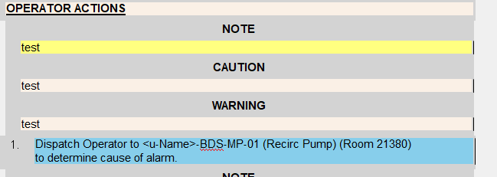

£ Print the procedure to verify that these are printed as centered:

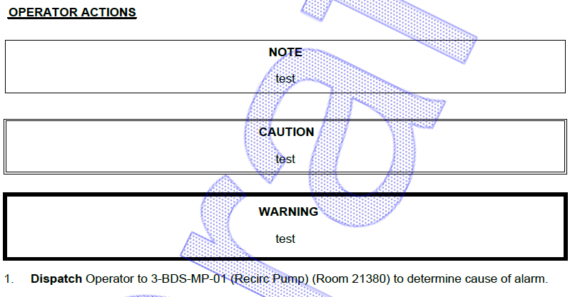
Changes/Additions to User Documentation: NA

