March 5, 2024

Applicability: Vogtle Units 3 & 4 Alarms

Internal Data Fixes: N/A

Internal Release:
F2024-025
Added a new Front Matter section that include the end message “END OF PROCEDURE TEXT”.

Generic External Release:
N/A

Plant Specific Information for Release Letter:
Vogtle Units 3 & 4
Alarm format
The "Front Matter with End Message - Step Editor" section type was added for use in the Local Alarms procedure set

Testing Requirements:
Use Vogtle data
- Update formats
- Change the section type of 8.0 in local alarm procedure ASS-ARP-010 to use the "Front Matter with End Message - Step Editor" section type

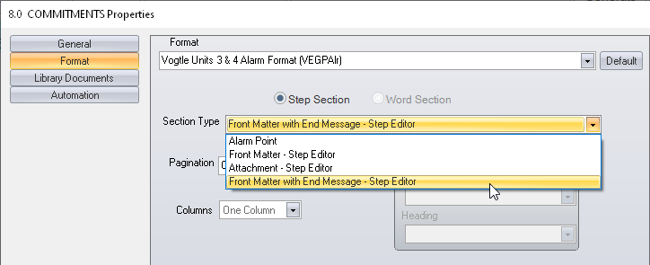

- Save and print the procedure
- Verify there is an end message at the end of section 8.0

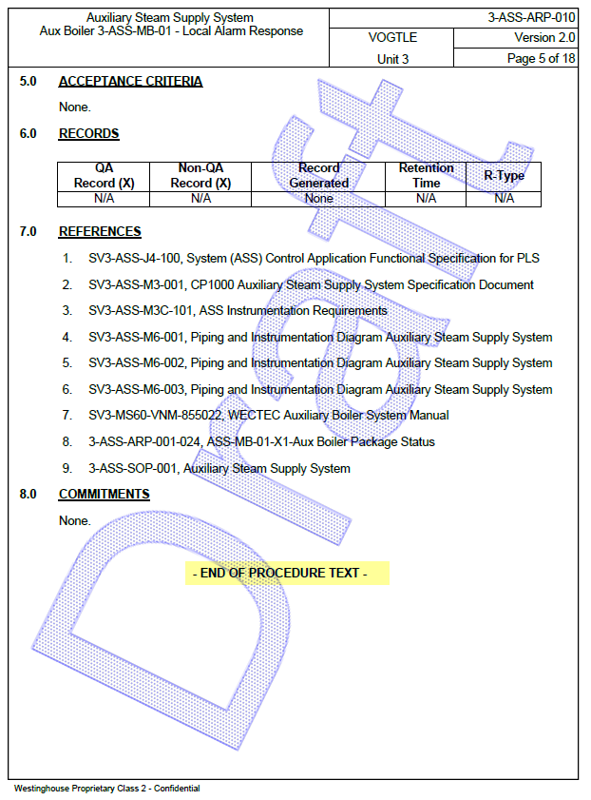

Changes/Additions to User Documentation:

N/A

