August 19, 2025

Applicability: GEN

Internal Release Information:
C2025-035 RO Performance Improvement

Add some code to rebuild specific indexes (like [IX_RofstID_DbiID_ParentID] ON [dbo].[RofstChild])
after a new RO.FST is imported.

- [Check this box if a sql query or a data fix applies to this update].

Generic External Release:
Improve RO Performance by adding some extra index maintenance after a new RO.FST is imported.

Plant Specific Information for Release Letter:
N/A

Testing Requirements:
- To see difference - Use DB at:
V:\Proms Versions\Test Version\Data to use for testing\C2025-035
- Open EP Practice – multi-unit -> 1ep,2epERG
- Go to Procedure Steps -> Step 1
- Open the EP test Annotation
(note – it will take a long time to open – you will have to wait for it to open – about 4 to 8 minutes)
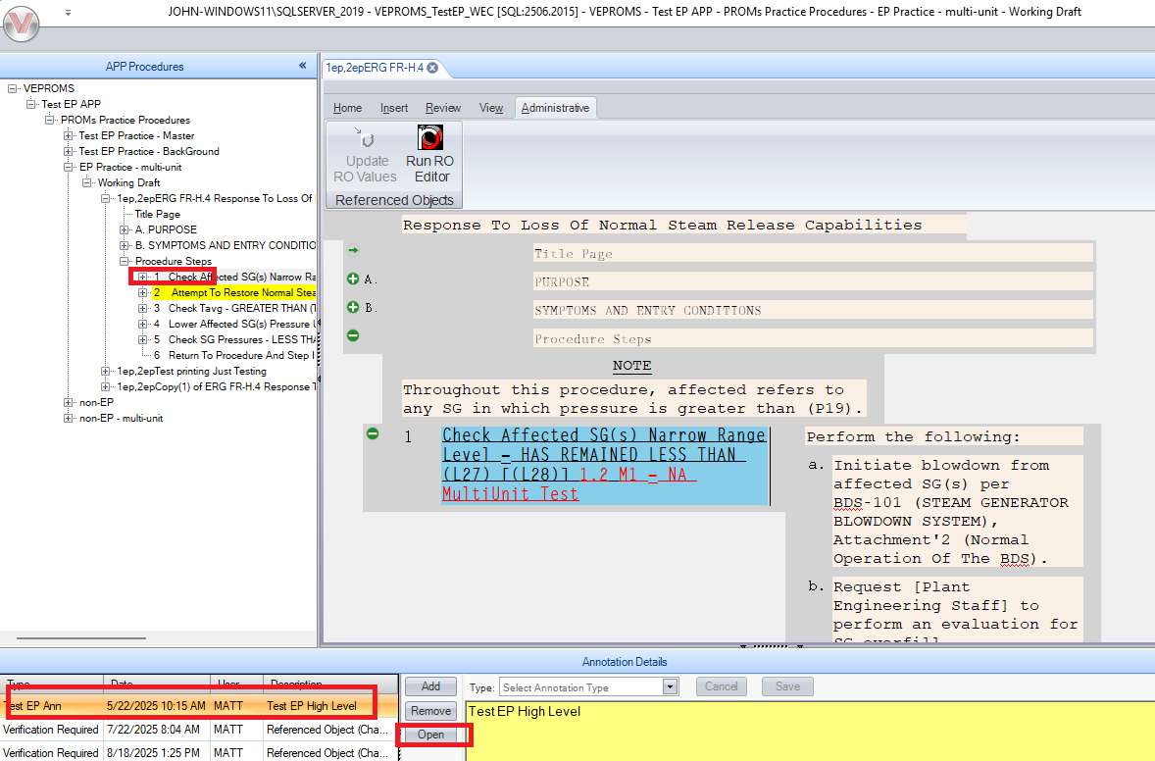

- Open the RO Editor
- Edit the Description text on the last Test -> Display item
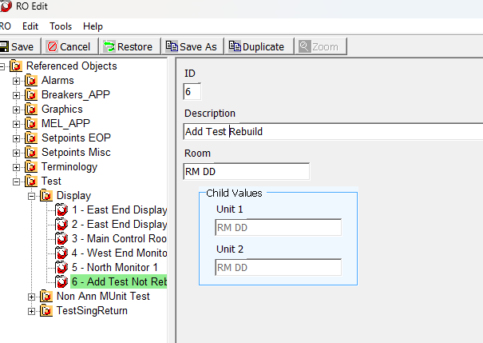
- Save and Create the RO.FST
- Test #1: In PROMS, update/import the new RO.FST using the “Update RO values” in the ribbon
- After it updates, perform the same check as before where you open the EP Annotation – It should now open quickly
- After this, reload the original DB with it being slow
- Perform the same updating and creation of a RO FST with item 6 text changed.
- Test #2: In PROMS, update/import the new RO.FST using the Admin Tool
- After it updates, perform the same check as before where you open the EP Annotation – It should now open quickly

Changes/Additions to PROMS Manual and Training Videos:
[Do not use this section – for MRV/DMJ use]
- CSM submitted for PROMS User Manual: ____________.
- CSM submitted for training videos: ____________.

