March 19, 2024

Applicability: Vogtle Units 3 & 4

Internal Data Fixes: N/A

Internal Release:
F2024-037
Adjustments made for single column sections of the Vogtle Units 3 & 4, including length of un-numbered HLS, resetting the sub-step numbering when staring under an un-numbered HLS, removed “Two Column” from the section type name Purpose and Symptoms Step Editor

Generic External Release:
N/A

Plant Specific Information for Release Letter:

N/A – format currently under development.

Testing Requirements:
Use Vogtle Units 3 & 4 data
- Update formats
- Expand EOP procedure FR-Z.3 and view the properties for the Purpose section and verify the section type is Purpose and Symptoms Step Editor.

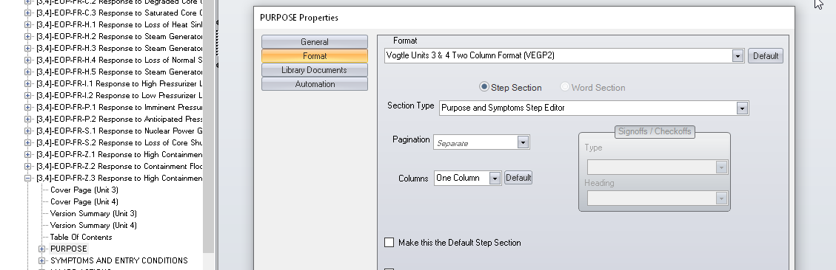

- Open the the procedure to the Purpose section.
- Add a sequential sub-step to the existing un-numbered HLS and verify the tab is a number

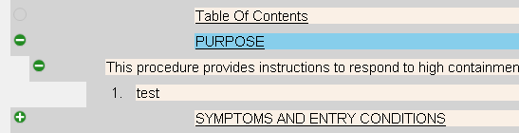

- Print the procedure
- Verify the text is indented under the section titles in the Purpose, Symptoms And Entry Conitions, and the Major Actions secrtions

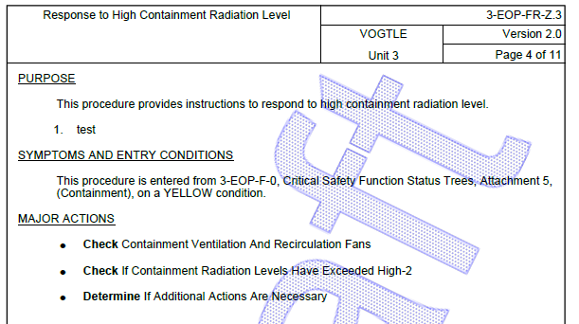

Changes/Additions to User Documentation:

N/A

