August 8, 2025

Applicability: GEN

Internal Release Information:
C2025-024 Electronic Procedures - PROMS XML output (Phase 2)

At the completion of this phase, we should be able to demonstrate ability of PROMS to output the basic information needed for use in Electronic Procedures.

note that this is a sub-item of:
C2024-032 Electronic Procedures – POC

- [Check this box if a sql query or a data fix applies to this update].

Generic External Release:
N/A

Plant Specific Information for Release Letter:
N/A

Testing Requirements:
- Use any DB that has been set up for EP use (db needs to have some multi-unit EP procedures, some non-multi-unit procedures, and some non-EP procedures).
- Can use setup instructions from C2025-023…
Or
- Can use preset up files from: V:\Proms Versions\Test Version\Data to use for testing\C2025-024…
- Procedures that have an EP Format should show the Export in the menu
  - No Parent Child
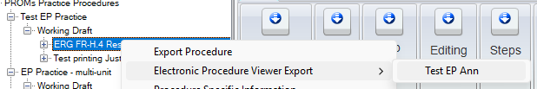
  - With Parent Child / multiple units
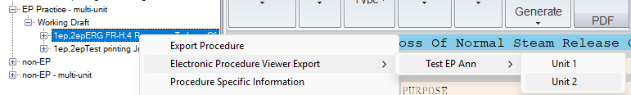
- If a Procedure does not have an EP Format, the Electronic Procedures Export should not show in the menu.
- Testing will require reviewing the xmls generated by the exports (Opening in Notepad/Notepad++).
- Export will follow the general PROMS xml export format and prompt with a few key additions mentioned below.
- All details supplied in an EP Annotation will export inside a <EPInfo> xml node.
  - ROs will properly resolve based on:
    - returncols specified in EP Format file for ROSINGLE/ROMULTI fields.
    - unit if multi-unit (Parent/Child)
    - <RO ACC TAGS> specified in TEXT fields will also resolve
      - If text, it will auto-resolve to the text
      - If it references an image, it will keep the tag and a xml sub-item will be created with that tag referencing the location and containing the binary data for the image.
- A textwithlinks field will be added to content nodes. This will contain the text without ROs/Transitions resolved. This way, we are providing both resolved/non-resolved and the EP Viewer can use whichever it needs based on its individual needs/capabilities. Similarly, A datawithlinks field will be added to grid nodes. And a doccontentwithlinks field will be added to document nodes.

- All RO images will contain a Location field that designates the file location/name of the image.
  - This will be in the rousage tag for items in PROMS normal UI
  - This will be in a tag named for the ROID when an image is referenced in an EP Annotation

- dbsequence will be added to step nodes to designate an item’s location (in the xml, it will be in the format Folder:Procedure:dbsequence from the item properties)
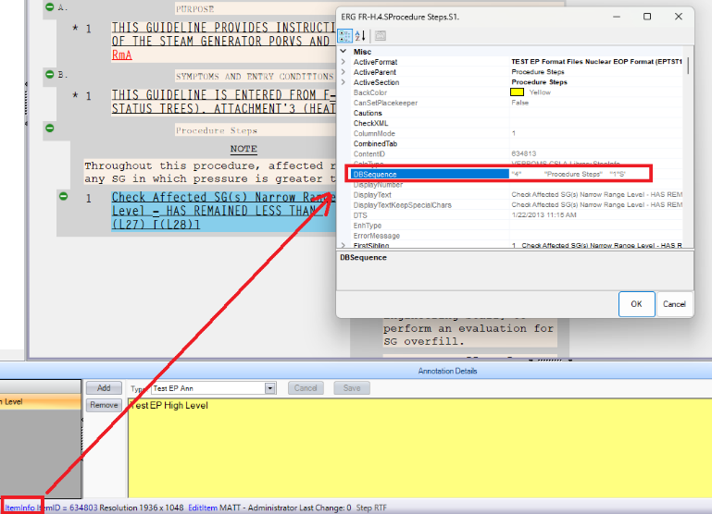

- StepTab will be added to step nodes: This will list the full step tab that would usually appear in a Referenced Object Usage Report. This may be useful for a EP Viewer to determine numbering/letters/bullets being used in a step tab.

- When an Export is done for a particular unit in cases where there are Parent/Child – that should reflect in the dbsequence, as well as ROs resolved with parent / child.

- TransitionToItemID & TransitionTodbsequence will be added to step nodes that contain transitions. These will be populated with the ItemID & dbsequence of the first transition within that specific step node.

- When an export is done on an item with enhanced documents (either a master or background documents), the EnhancedDocType, EnhancedDocToItemID, & EnhancedDocToDbSeq are set on the content xml node.

Changes/Additions to PROMS Manual and Training Videos:
[Do not use this section – for MRV/DMJ use]
- CSM submitted for PROMS User Manual: ____________.
- CSM submitted for training videos: ____________.

