August 5, 2025

Applicability: All plants

Internal Release Information:
B2025-036 split screen print issue.
When two procedure screens are open side by side and one of them has the focus (cursor is in a step field). If you click the print button in the other screen trying to print that procedure the other procedure (the one that has focus) is printed.
SQL updates included.

Generic External Release:
When two procedures are open side by side the correct procedure is printed even if the other screen has focus.

Plant Specific Information for Release Letter:
N/A

Testing Requirements:
- USE DB VEPROMS_BeaverValley
- Open procedure EOP/Unit 1/Working Draft/ES-0.0 Rediagnosis.
- Open procedure EOP/Unit 2/Working Draft/ES-0.0 Rediagnosis.
- Drag Unit 2 ES-0.0 Rediagnosis to open it in the right screen. Unit 1 should be in the left screen.
- Click in a step in the right screen.
- Click the print button in the left screen.
- The procedure in the left screen should print.

Images:

PROMS App.

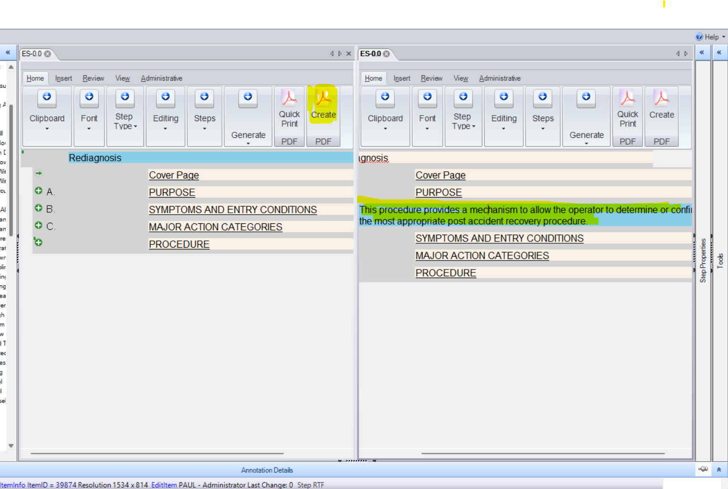

Print Dialog

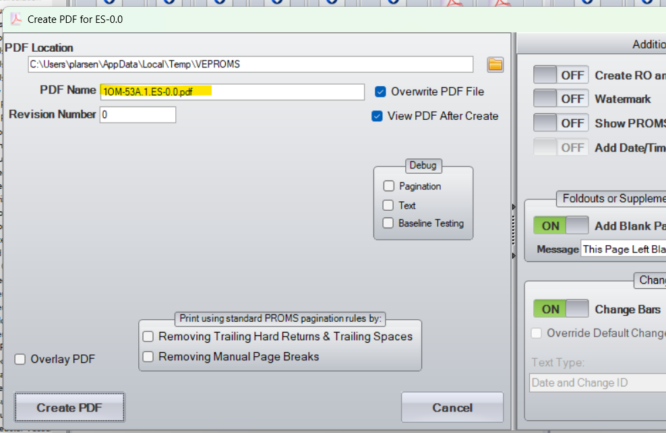

Print output

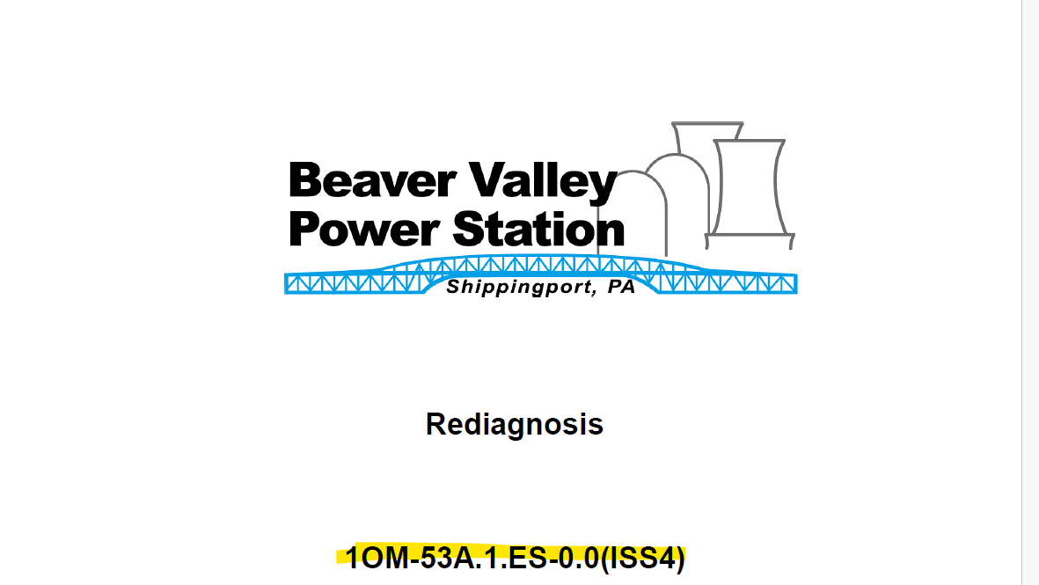

Changes/Additions to PROMS Manual and Training Videos:
[Do not use this section – for MRV/DMJ use]
- CSM submitted for PROMS User Manual: ____________.
- CSM submitted for training videos: ____________.

