July 17, 2026

Applicability: V.C.Summer

Internal Release Information:
F2026-017
Blank line was sometimes missing after the Note and Caution text. This was a 64-bit build difference that affected the text width calculations. To fix, added one to the defined text width inside the Caution/Note box format settings.

- [Check this box if a sql query or a data fix applies to this update].

Generic External Release:
N/A

Plant Specific Information for Release Letter:
V.C. Summer EOP and SAMG formats:
- A minor adjustment to the text width of Cautions and Notes was needed to correct word wrapping within the Caution and Note boxes. As a result, some Caution and Note word wrapping may be different from your previous PROMS version.

Testing Requirements:
Use V.C. Summer data
- Update formats
- Print AOP 117.1 and verify on step 10 that there is blank space between the last line of Note text and bottom of the Note box.

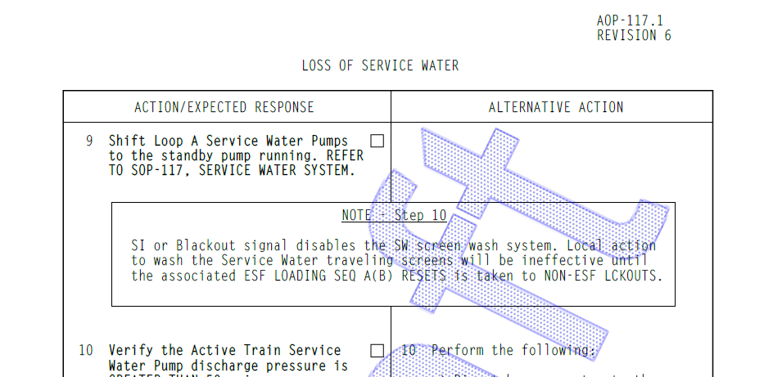

- Print AOP-900.05 and verify in Attachment 27 on step 3 that there is blank space between the last line of Note text and the first item in the equipment list

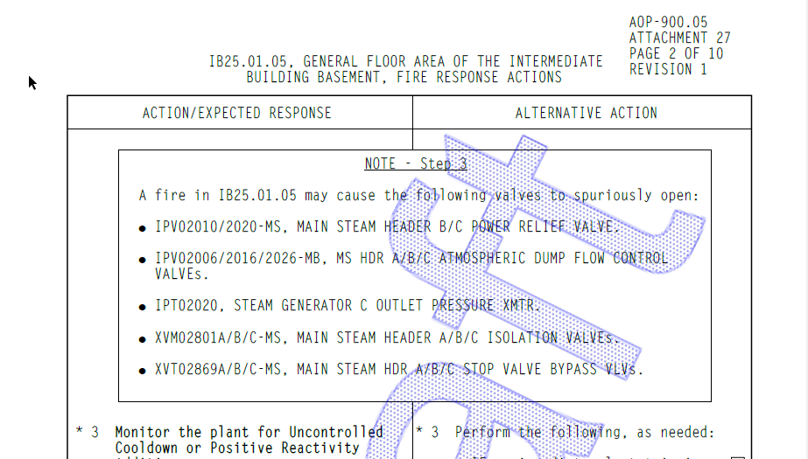

Changes/Additions to PROMS Manual and Training Videos:
[Do not use this section – for MRV/DMJ use]
- CSM submitted for PROMS User Manual: ____________.
- CSM submitted for training videos: ____________.

