November 28, 2023

Applicability: Vogtle Units 3&4 Alarm format

Internal Data Fixes: N/A

Internal Release:
F2023-144
Needed to move the ReplaceWords item for “Return To” to before the one for “Return” so that “Return To” will be bolded and title cased.
F2023-147
Added “Supply/Return” to ReplaceWords so that it is not bolded.
F2023-148
Added “See” to ReplaceWords so that it is Title Cased and Bolded no matter what case it is typed as.

Generic External Release:

N/A

Plant Specific Information for Release Letter:

N/A – format under development

Testing Requirements:
Use Vogtle Units 3 & 4 data
Update formats
Edit Alarm Point procedure DAS-ARP-001-010 and expand Operator Actions
Undo the manual bolding of “To” and move off the edit window.
Verify “Return To” is now bolded

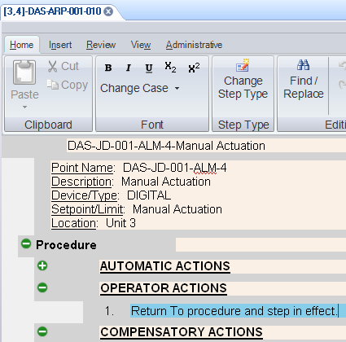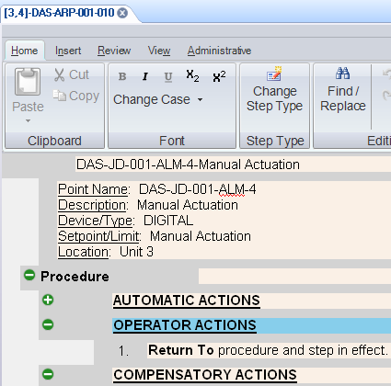

Print the alarm point page and verify “Return To” is bolded

Edit Alarm Point procedure MTS-ARP-001-287 and expand Operator Actions
Verify “Supply/Return” is Not bolded

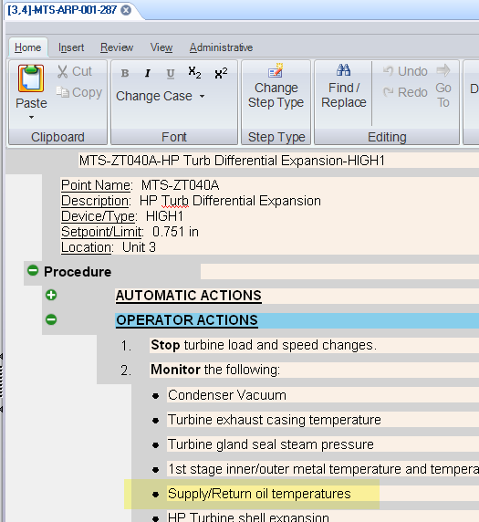

Print the alarm point page and verify “Supply/Return” is Not bolded

Edit Alarm Point procedure CDS-ARP-001-001 and expand References
Verify See” is bolded
Print and verify it’s bolded in the PDF

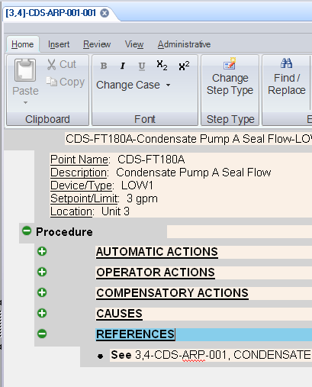

Changes/Additions to User Documentation:

N/A

