July 21, 2026

Applicability: GEN

Internal Release Information:

C2026-046 - Decrease check if need to update ROs.

When opening a procedure in a Working Draft, if there exists an applicable RO FST that is newer than the one used for the current set - it will ask the user if they want to update the ROs. This change will decrease the number of times this is asked. If this is asked for a working draft and No is selected, it now will now no longer re-ask for that working draft until either exiting and re-entering PROMS or if ROs are updated for any set.

Note - due to the way that PROMS behaves with events - a double ask is always still technically possible, but this should reduce the chances of that occurring.

- [Check this box if a sql query or a data fix applies to this update].

Generic External Release:
This is an update to C2026-008 - When opening a procedure in a Working Draft, if there exists an applicable RO FST that is newer than the one used for the current set - it will ask the user if they want to update the ROs to keep them consistent. This change is to decrease the number of times this is asked by: If this is asked for a working draft and No is selected, it now will now no longer re-ask for that working draft until either exiting and re-entering PROMS or if ROs are updated for any set.

Plant Specific Information for Release Letter:
None

Testing Requirements:

Test 1 – Test Update via Step Tab Ribbon
- Use any Data where multiple sets use the same ROs
- Using the current version of PROMS, update values using the RO FST by clicking on the Update RO Values button in the Step Tab Ribbon for (Procedure A/Set A)
- Once the progress bar at the bottom designates that ROs have updated, open another procedure in a different working draft folder that uses the same ROs (will call this 2nd one Procedure B/Set B)
- It should prompt:
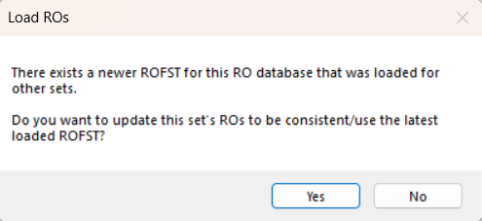
- Select No.
- Change to another procedure from a different working draft then change back to (Procedure B/Set B) – it should not prompt
- Close PROMS and re-open the same procedures, it should prompt on the one it previously asked on (Procedure B/Set B).
- Go back to the original procedure (Procedure A/Set A) that should have the updated RO.FST
- Create a new RO.FST using the RO Editor and update it again.
- Swap back to (Procedure B/Set B) – it should now prompt again if want to update this set’s ROs.

Test 2 –Test Update via Version Properties
- Use any Data where multiple sets use the same ROs
- Using the current version of PROMS for (Procedure A/Set A), update values using the RO FST by clicking on the Working Draft -> Properties -> Referenced Objects -> Update RO Values
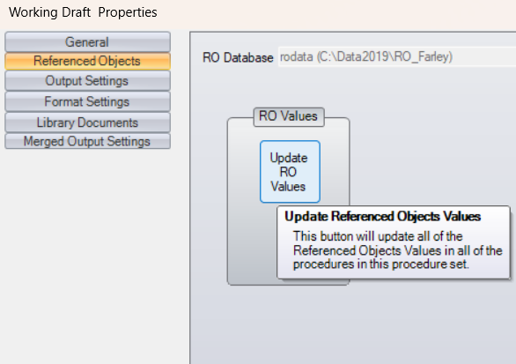
- Once the progress bar at the bottom designates that ROs have updated, open another procedure in a different working draft folder that uses the same ROs (will call this 2nd one Procedure B/Set B)
- It should prompt:
- Select No.
- Change to another procedure from a different working draft then change back to (Procedure B/Set B) – it should not prompt
- Close PROMS and re-open the same procedures, it should prompt on the one it previously asked on (Procedure B/Set B).
- Go back to the original procedure (Procedure A/Set A) that should have the updated RO.FST
- Create a new RO.FST using the RO Editor and update it again via clicking on the Working Draft -> Properties -> Referenced Objects -> Update RO Values
- Swap back to (Procedure B/Set B) – it should now prompt again if want to update this set’s ROs.

Test 3 –Test Update via Tree View
- Use any Data where multiple sets use the same ROs
- Using the current version of PROMS for (Procedure A/Set A), update values using the RO FST by Clicking on the Tree and Working draft -> Update RO Values
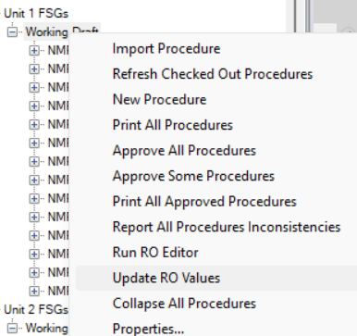
- Once the progress bar at the bottom designates that ROs have updated, open another procedure in a different working draft folder that uses the same ROs (will call this 2nd one Procedure B/Set B)
- It should prompt:
- Select No.
- Change to another procedure from a different working draft then change back to (Procedure B/Set B) – it should not prompt
- Close PROMS and re-open the same procedures, it should prompt on the one it previously asked on (Procedure B/Set B).
- Go back to the original procedure (Procedure A/Set A) that should have the updated RO.FST
- Create a new RO.FST using the RO Editor and update it again using the Tree.
- Swap back to (Procedure B/Set B) – it should now prompt again if want to update this set’s ROs.

Test 4 – Test Update via Admin Tools
- Use any Data where multiple sets use the same ROs
- Using the current version of PROMS, update values using the RO FST by utilizing the Admin Tools Update ROs
V button -> Administrative Tools -> Links -> Update RO Values
Select 1 set (Procedure A/Set A) to update
- Once the progress bar at the bottom designates that ROs have updated, open another procedure in a different working draft folder that uses the same ROs (will call this 2nd one Procedure B/Set B)
- It should prompt:
- Select No.
- Change to another procedure from a different working draft then change back to (Procedure B/Set B) – it should not prompt
- Close PROMS and re-open the same procedures, it should prompt on the one it previously asked on (Procedure B/Set B).
- Go back to the original procedure (Procedure A/Set A) that should have the updated RO.FST
- Create a new RO.FST using the RO Editor and update it again.
- Swap back to (Procedure B/Set B) – it should now prompt again if want to update this set’s ROs.

Changes/Additions to PROMS Manual and Training Videos:
[Do not use this section – for MRV/DMJ use]
- CSM submitted for PROMS User Manual: ____________.
- CSM submitted for training videos: ____________.

