January 29 2025 (Re-write of original GIT update from 1/27/25)

Applicability: All plants

Internal Release Information:
C2019-025 - Add a check box to Step Properties to toggle use of Replace Words.

Generic External Release: UPGRADE
- The “Show Replace Words” option has been added to the PROMS System Options located on the V Button. When selected, replace words will display in blue.
- A checkbox has been added to the Properties|Format tab for procedure sections. The “Show Replace Words” option is selected automatically by default and all of the steps in the section will default to “Inherit from Section” in the Show Replace Words frame in the Step Properties|Tags panel. When this option is not selected, replace words will appear as normal text.

Plant Specific Information for Release Letter: N/A

Testing Requirements:
Note that testing for the Step Level options will be performed when C2025-010 has been completed.
- Use the PROMS Ginna database.
- Open PROMS and go to Options on the V button. Verify the Replace Words frame is there and check the box “Color Replace Words”. Click OK and close the Options. The ONLY thing this does is turn the color of the replace words to blue so that they can be easily recognized. If the Show Replace Words option is not checked at the section level nor on the individual step, the replace words will NOT be blue.

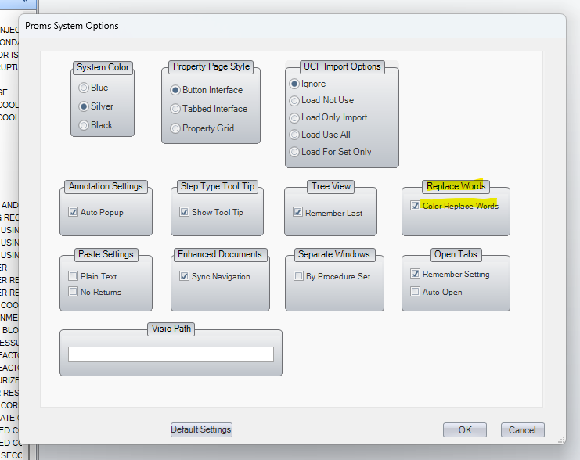

- Go to EOP procedure ES-0.0.
- In tree view, right click on the Procedure Steps section, select Properties then select the Format tab. Verify the Show Replace Words checkbox is selected. Whether this box is checked or not determines the default setting for all steps within the section (i.e. if checked, all steps will default to showing replace words).

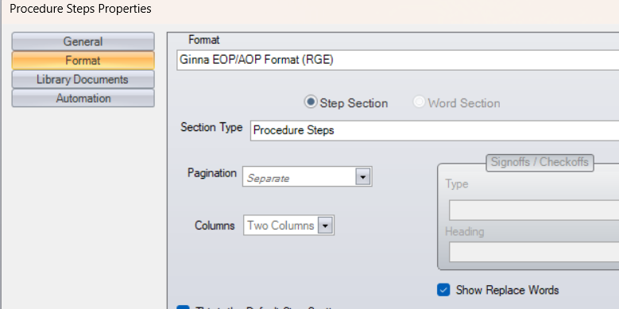

- Open the procedure steps section in the edit window and add replace words to various steps (such as AND, OR, IF NOT, IF, WHEN, NOT). Move off the step(s). Verify that the replaced words are underlined and colored in blue.

- In tree view, right click on the Procedure Steps section, select Properties then select the Format tab. Uncheck the Show Replace Words checkbox.
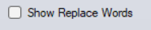

- Open the procedure steps section in the edit window and go the steps where replace words were added previously. Verify that the replaced words are no longer underlined and are not blue.

Changes/Additions to PROMS Manual and Training Videos:

- CSM submitted for PROMS User Manual: ____________.
- CSM submitted for training videos: ____________.

