September 16, 2025

Applicability: GEN

Internal Release Information:

C2021-058 Admin Tool Purge Change History/C2025-052 Admin Tool Index Maintenance

C2021-058 Admin Tool Purge Change History - Add the ability to remove audit records from Admin Tools.

C2025-052 Admin Tool Index Maintenance - Add "Index Maintenance" functionality to Admin Tools.

- [Check this box if a sql query or a data fix applies to this update].

Generic External Release:
Added the ability to perform index maintenance as well as the ability to purge old audit records to a new Maintenance tab in the Admin Tools. The new Purge Change History function will delete audit records (change history) older than the specified date. It will also remove any deleted items older than the specified date (resulting in the items no longer being able to be restored through PROMS).The Purge Change History functionality will only be available to “Full Admin” users.

Plant Specific Information for Release Letter:
N/A

Testing Requirements:
- Use Any DB
- Go to: V-button->Administration->Administrative Tools-> Maintenance Tab
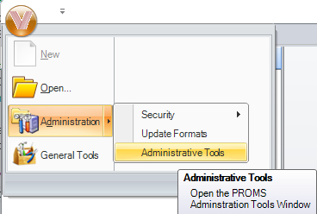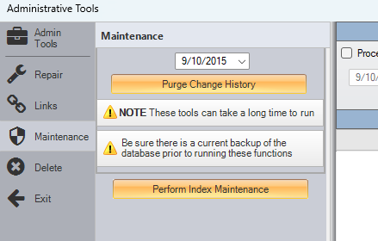
- If user is only a Set Administrator (and not a full Administrator), “Purge Change History” button will be disabled, and they will receive a pop-up message. They will still be able to run “Index Maintenance”
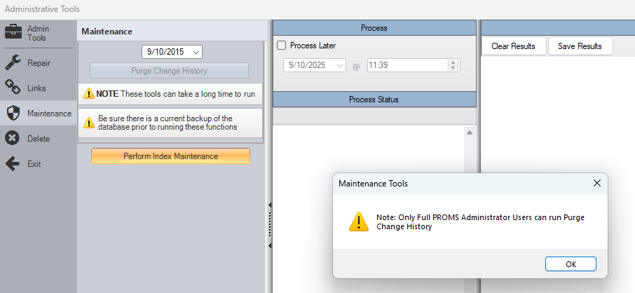
- If a user attempts to run Index Maintenance or Purge Change History and there are other users active in the same PROMS db, it will provide a prompt and exit without running. (Other) Users in PROMS will be listed in the Process Status box.
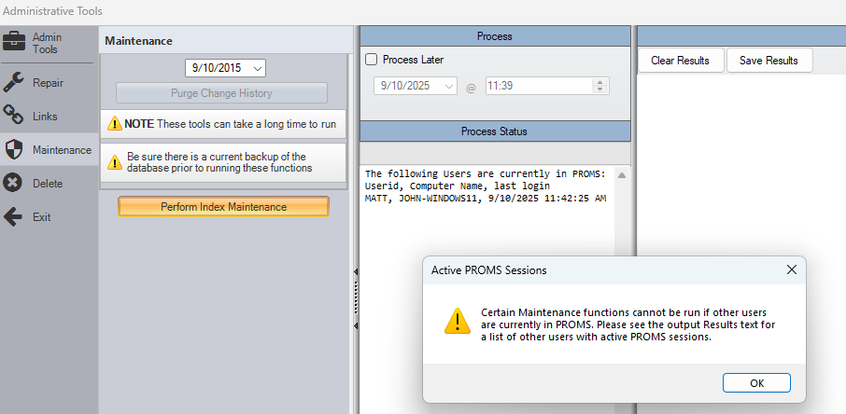

- Mousing over each of the buttons (Purge Change History/Perform Index Maintenance) should provide tooltips that describe the actions of the buttons.
- Running “Perform Index Maintenance” should rebuild all indexes for tables that have data.
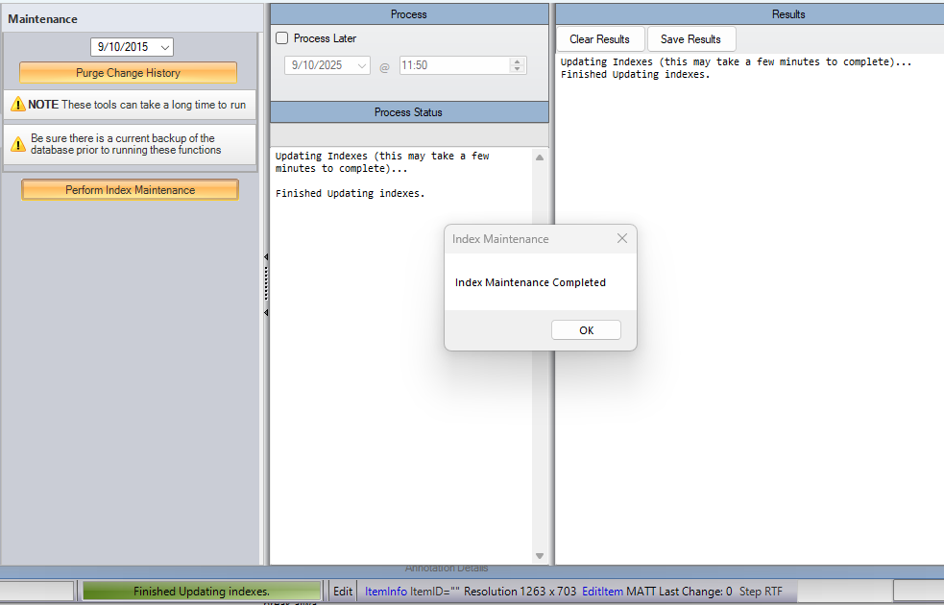
Can confirm this after running with the following query:
SELECT
STATS_DATE(i.object_id, i.index_id) AS LastStatisticsDate
,o.Name AS TableName
,i.name AS IndexName
, o.modify_date
FROM sys.objects o
INNER JOIN sys.indexes i ON o.object_id = i.object_id
WHERE o.is_ms_shipped=0 and o.type='U'
ORDER BY 1 DESC

- Running “Purge Change History”, it will check if the user is sure they want to perform the action:
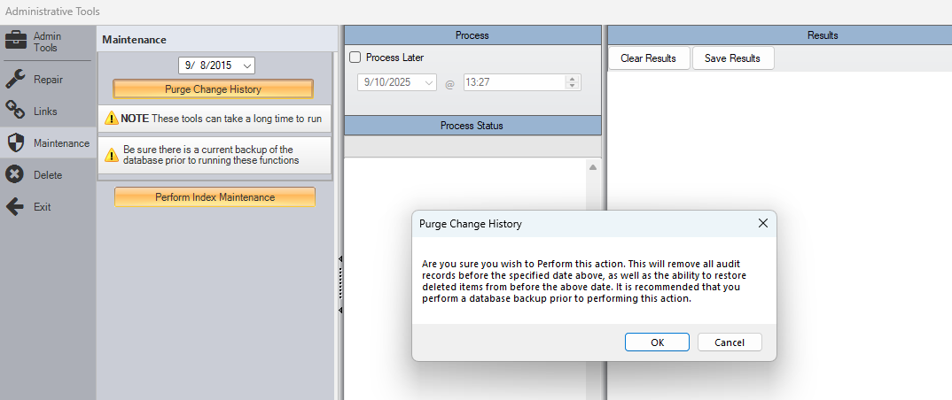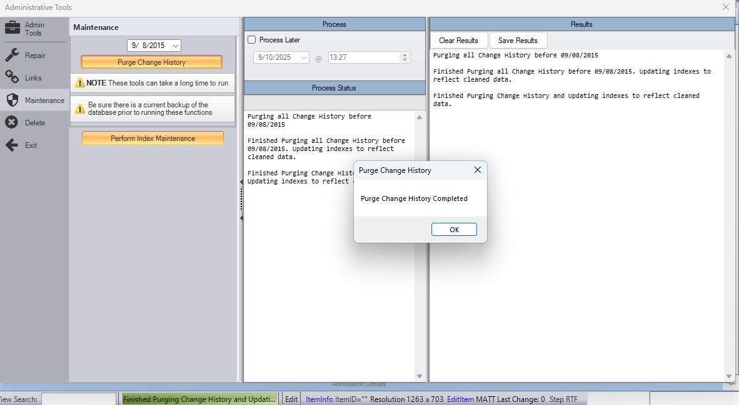
- Running “Purge Change History” should delete the following types of records older than the specified date (note: date defaults to 10 years ago):
- Stored in PROMS Versions records
- RO Figures with no Associations
- Old ROFSTs with no Associations
- roimages no longer in rofsts
- documents with no matching entries
- Annotations that were previously deleted
- drousages where the document was deleted
- Entries that were previously deleted
- Documents that were previously deleted
- Grids that were previously deleted
- Images that were previously deleted
- ROUsages that were previously deleted
- Transitions that were previously deleted
- Parts that were previously deleted
- Items that were previously deleted and do not have any related Parts
- Contents that were previously deleted
- AnnotationAudits
- ContentAudits
- EntryAudits
- DocumentAudits
- GridAudits
- ImageAudits
- ItemAudits
- PartAudits
- ROUsageAudits
- TransitionAudits

Changes/Additions to PROMS Manual and Training Videos:
[Do not use this section – for MRV/DMJ use]
- CSM submitted for PROMS User Manual: ____________.
- CSM submitted for training videos: ____________.

