Date: 12/20/2023

Applicability: All customers

Internal Data Fixes: N/A

Internal Release:

Add an option to the Help dropdown menu that will open File Explorer to the folder containing the Error Log, and to the location containing Export Files. This would be helpful for non-computer savvy users to locate these types of PROMS files.

Generic External Release: N/A

Plant Specific Information for Release Letter: N/A

Testing Requirements:

- Use any database
- Open the Help Menu in the upper right corner.
- Click on the “Open Error Folder” link.
- A File Explorer window should open to the “VEPROMS” folder in your documents folder.

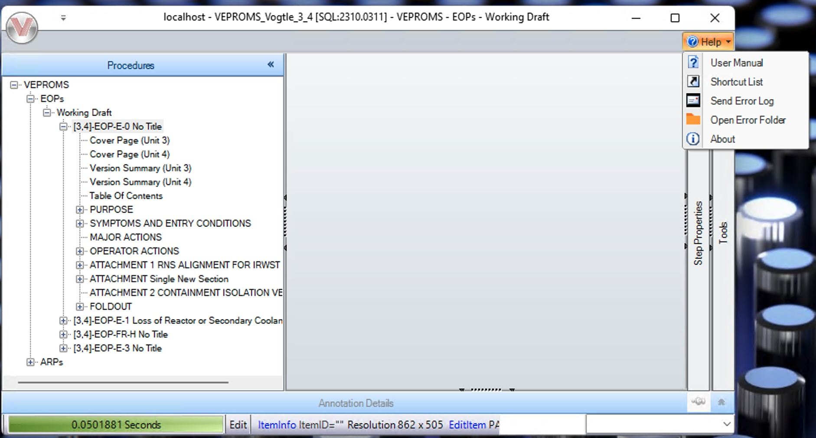

- Verify that the new “Open Error Folder” link works in the screen shot below.

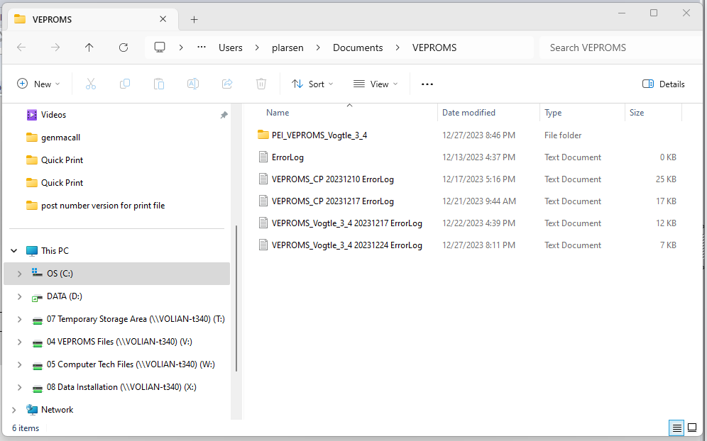

Changes/Additions to User Documentation:

Now within PROMS a user can open the folder that contains PROMS error information and Export Files. The new link is located in the Help Menu in the upper right corner of the application. The link is called “Open Error Folder”.

