10/10/2023

Applicability: C2023-018: Upgrade to paginate sub-steps

Internal Data Fixes: NA

Internal Release:

C2023-018: Upgrade to paginate sub-steps. This was implemented in a similar way to the preferred pagination setting for Supplemental Information. Note this supersedes the change made for C2023-015 which was only for Vogtle 3_4 Alarms and had an added checkbox ‘Substep page Break’, which was removed for C2023-018. The Step Properties/Tags/Manual Page Break check box is now available under the following conditions:
- Only for Single column procedures.
- Only allow for sequential sub-steps.
- Only allow it for first level sub-steps
- Will not be supported in Supplemental information or in Enhanced Procedures

Also, for the dialog that is displayed after printing if manual page breaks exist, the message in the dialog has been clarified.

Generic External Release:

Upgrade: This update allows the user to place a manual page break on a sequential sub-step in single column procedures. The Step Properties/Tags/Manual Page Break check box can be used to set the page break on the sequential sub-step if it is at the first level, i.e. immediately below a High Level Step. This is not available for Supplemental information or in Enhanced Procedures. Also, for the dialog that is displayed after printing if manual page breaks exist, the message in the dialog has been clarified.

Plant Specific Information for Release Letter: NA

Testing Performed:

See Testing Required.

Testing Requirements:

Test for single column; sequential only; and first level:
Using BGE sql database:
£ Bring up OI Unit 1/OI-1I/6.0/6.1/B Procedure in the editor (id=1548214)
£ Position on the Note & expand the Step Properties/Tags tab to verify that the ‘Manual Page Break’ checkbox is disabled
£ Position on HLS 1 to verify that the ‘Manual Page Break’ checkbox is enabled
£ Position on sub-steps a. and b. to verify the ‘Manual Page Break’ checkbox is enabled
£ Insert a sequential sub-step off b. to verify the ‘Manual Page Break’ checkbox is disabled
£ Position on sub-step c. and check the ‘Manual Page Break’ checkbox
£ Print the procedure to verify that sub-step c starts at the top of a page
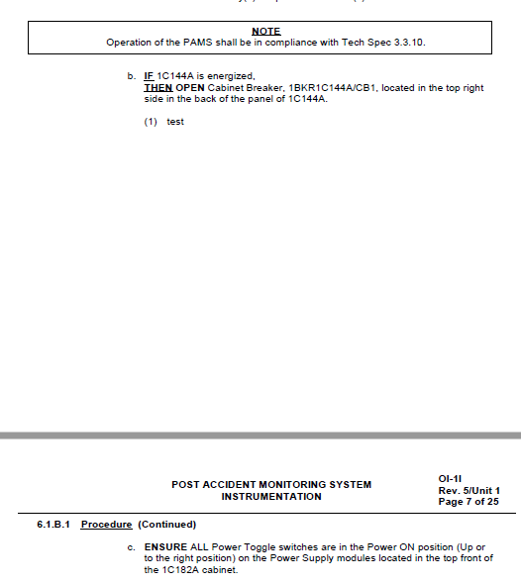

£ Print the procedure but this time check the ‘Removing Manual Page Breaks’ check box to verify that the pdf does not break on sub-step c & a dialog is displayed asking if the Manual Page Breaks should be permanently removed.
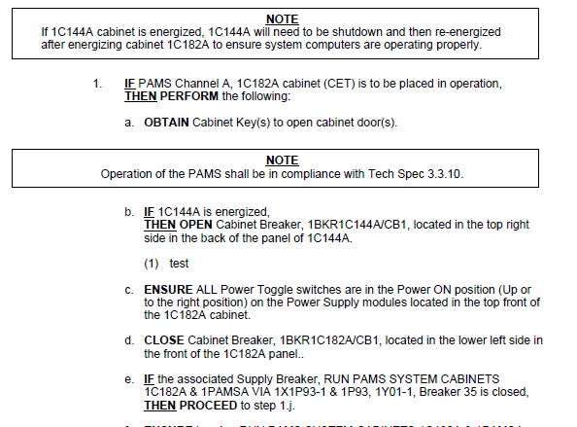
£ On the dialog select Yes to permanently remove the Page Break, move cursor to another step and back (Step Properties/Tags/Manual Page Break check box is only refreshed if move off/on to step) to verify that the box is no longer checked. Also verify that an annotation was placed on the step:
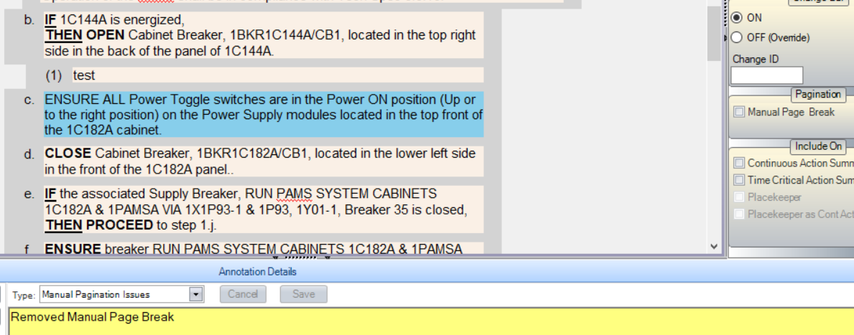

£ Reprint to verify that the break no longer exists.
£ Add the Manual Page Break back on sub-step b, i.e. using check box. Print, Removing Manual Page Breaks to verify that the following dialog is displayed:

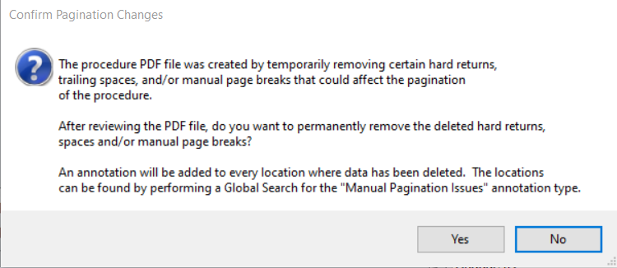

Test for enhanced and supplemental info, i.e. check box not available:
Using the Ginna sql database:
£ Bring up SAG-3/Guideline Steps/HLS 1/sub-step 1 (id=49549) in the editor to verify that Step Properties/Tags Manual Page Break checkbox is disabled
£ Bring up various Enhanced Background Documents steps in the editor to verify that Step Properties/Tags Manual Page Break checkbox is disabled

Changes/Additions to User Documentation:

Add the availability of the Manual Page Break check box for sub-steps with the following restriction:
- Only for Single column procedures.
- Only allow for sequential sub-steps.
- Only allow it for first level sub-steps
- Will not be supported in Supplemental information or in Enhanced Procedures

Also, if user documentation includes an image of the dialog that is displayed after printing a procedure that has Manual Page Breaks, update the image to show the new clarified wording.

